Методична розробка уроку – гри на тему : “The trip around the USA”

(9 -10 клас)

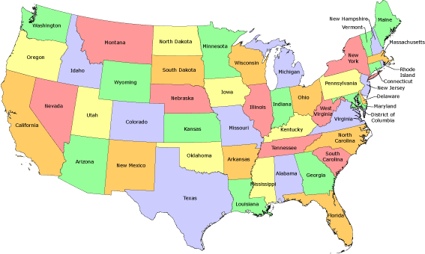

Вчитель англійської мови Веселинівської ЗОШ І – ІІІ ступенів Миколаївської області
Латій Ольга Олександрівна

The theme: The trip around the USA
Objectives: to revise all the vocabulary on the topic “The USA”;
to get pupils know more about the country, its traditions, history and culture and to
broaden their outlook;
to develop the skills of speaking, pronunciation, reading, writing, listening on the basis of the country – study material about the USA;
to develop pupils’ skills of group – work, pair – work;
to develop their acting skills;
to bring up the pupils’ creativity, cooperation, respect to teach other;
Equipment: cards with the tasks, the map of the USA, pictures of the USA sights, projector, flags
Lesson Procedure
- Introduction
- Greeting
- Introducing the theme and the aim of the lesson.
- Hello everybody! I hope you are very well. You can see a map of the USA on the board and many beautiful pictures (video file). They are not new for you. For some time we have been learning many interesting things about the USA. You’ve got to know that the USA is the richest and highly developed country in the world. It stretches from coast to coast. Today we’re going to concentrate on the different interesting facts about the USA. At today’s lesson we are going to sum – up the results of our work during our trip.
For this purpose we need two teams. Each team consists of seven players and a captain. Each team has its own desk with a flag on it. The teams will be given tasks. If the player knows the answer the captain should raise the flag. Only then the player can answer. For each correct answer you’ll get two points and for an incorrect answer you’ll get one point. The jury will keep the score and define the winner of our game. Good luck and let’s start.
- Warming –up.
- In the past only the rich people travelled for pleasure and education. But recently travelling has become les expensive and people have more money to spend. These days more and more people go abroad on holiday. So, let’s organize a travel agency in our classroom.
- Role- playing the situation.
Imagine that Mr&Mrs Sydorenko have come to travel agency. They have 2 children of 6 and 13 years old. They‘d like to arrange their holidays/ have they got any attractive offers of them? – It’s of course Disney World in Orlando, the state of Florida. It doesn’t need any recommendations/ it’s a wonderful place for both children and adults. Who wants to be Mr. and Mrs. Sydorenko? I believe two travel agents are going to offer such an attractive place.
- Main part of the lesson
- We will travel from one station to another. Captains, please, introduce your teams. So let’s begin!
Station 1 Geography of the USA
- What is the longest river in the USA? ( The Mississippi)
- What is the ocean in the west of the USA? (The Pacific Ocean)
- What territory belonged to Russia? (Alaska)
- What is the ocean in the east of the USA? (The Atlantic Ocean)
- What are two separated parts of the USA? (Hawaii, Alaska)
- What is the highest peak? ( Mount McKinley, Alaska, 6, 194m)
- What is the lowest point? (Death Valley, Nevada, California, 85m below sea level)
- What is the highest waterfall? (Yosemite Falls in Yellow Stone National Park)
- What deserts are there in the USA? ( The Painted Desert, the Gila Desert)
- What is the climate of the USA? (Most of the country has a humid continental climate)
- What is the population of the USA? (265, 455, 000)
- How is the Mississippi called? (“the father of waters”)
- Where are the Niagara Falls? (on the Niagara River)
- What natural resources is the USA rich in? ( oil, natural gas, coal, copper, gold, iron, lead , aluminum)
- Name the longest rivers of the USA. (the Mississippi, the Missouri, the Colorado, the Yukon, the Arkansas, the Rio Grande)
- What are the biggest lakes in the country? (Lake Superior, Lake Michigan, Lake Huron, Lake Erie, Lake Ontario, Great Salt Lake)
- What mountains are there in the USA? (The Appalachian Mountains, the Rocky Mountains, the Sierra Mountains, the Cascade Mountains, the Cordillera Mountains)
- What kind of state is the USA? (federal union of 50 states)
- What river is the capital of the USA situated? (the Potomac River)
- What is the total area of the USA? (3, 717522 sq.miles)
- What is the longest lake in the USA? (The Lake of the Woods)
- How many economical regions are there in the USA? (6)
- How many Ukrainians live in the USA? (more than 1 mln people)
- What ocean doesn’t wash the USA? (The Indian Ocean)
- What mountains are not situated on the territory of the USA: the Cordilleras, the Rocky Mountains and the Cumbrian Mountains? (The Cumbrian Mountains)

Station 2 History of the USA
- When did Christopher Columbus discover America? (1492)
- Who were Native Americans? (Indians)
- How did Europeans call America? (New World)
- How did Indians call Englishmen who came to America? (Yankee)
- Who was the first president of the USA? (George Washington)
- What was the name of the ship which brought the first immigrants to America? (“ Santa Maria”)
- What is the most important part of the Constitution? ( The Bill of Rights)
- What president made American slaves free? (Abraham Lincoln)
- What are the main political parties in the USA? ( The Democratic Party, the Republican Party)
- What is the official name of the country ? (the United States of America)
- America is called the “melting pot” and … (“the nation of immigrants”).
- What is the main duty of Congress? (to make laws)
- Who is the chairman of the House of Representatives? (the Speaker)
- What government body is at the head of the judicial branch? (the Supreme Court)
- Who is the executive branch headed by? (by the President)
- What does Congress consist of? (the House of Representatives and the Senate)
- What does the US government consist of? (legislative, executive, judicial branches)
- When did the America became independence? (1776)
- When did the ship “Mayflower” bring a group of English Protestants to America? (1620)
- When did George Washington became the President? (1789)
- When did settlers from England first come to America? (1600)
- How many years did the Civil War last in the USA? (4 years)
- How many senators are there in the Senate? (100)
- How many years did the War of Independence last? (8 years)
- After whom was America called? (after Amerigo Vespucci)
Station 3 The states of the USA
a)
- What states in the USA is called “The Bread and Butter State”? (Minnesota)
- What state of the USA is called “The Lake State”? (Michigan)
- What state of the USA is called “The Sunflower State”? (Kansas)
- What state of the USA is called “The Land of Lincoln”? (Illinois)
- What state of the USA is called “The Salt Lake State”? (Utah)
- What state of the USA is called “The Great Land”? (Alaska)
- What state of the USA is called “the first state”? ( Delaware)
- What is the biggest state in the USA? (Alaska)
- What state is famous for its 15,000 lakes? (Minnesota)
- What state is midway between the oceans? (Kansas)
- What state is famous for aviation manufacture? (Washington)
- What is the smallest state in the USA? (Rhode Island)
- What state of the USA is called “The Golden State”? (California)
- What state of the USA is called “The Sunshine State”? (Florida)
- What state of the USA is called “The Apache State”? (Arizona)
- What state of the USA is called “Treasure State”? (Montana)
- What state of the USA is called “Silver State”? (Nevada)
- What state of the USA is situated on an island? (Hawaii)
- What state of the USA is called “Magnolia State”? (Mississippi)
- What state of the USA is called “The Child of Mississippi”? (Louisiana)
- What state of the USA is called “The Lone Star State”? (Texas)
- What state is home of the cotton gin machine? (Georgia)
- Where is Hawaii? (in the Pacific Ocean)
- What is the origin of the name of Colorado? (Spanish for red)
- What is the nickname of Alabama? (Cotton State)

b) Guess the name of the state
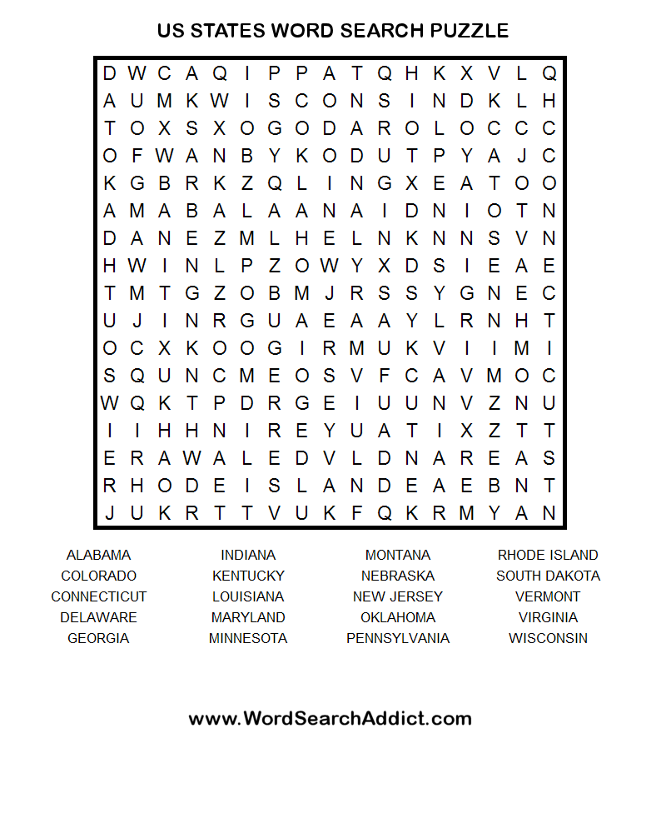

Station 4 The sights of the USA
a)
- Where does the president live and work? (in the White House)
- What place in the USA called “The Magic Kingdom”? (Disney World, Florida)
- Where is the Statue of Liberty situated? (New York)
- How many floors does the Empire State Building have? (102)
- What is the tallest building in the USA? (the Wills Tower)
- How many rooms are there in the White House? (132)
- Where the main headquarters of the United Nations? (in New York)
- How long is Broadway? (about 21km)
- What is the oldest public building in Washington? (the White House)
- How many theatres are there on Broadway? (more than 30)
- What is the address of the White House? (1600, Pennsylvania Avenue)
- How many floors does the Sears Tower have? (110)
- Where is the Jefferson Memorial? (District of Columbia)
- Where is the oldest zoo in the USA? (Philadelphia)
- What are the most interesting places in Buffalo? (The Niagara Falls, The Buffalo Museum of Science, The Buffalo Historical Museum and Zoological Gardens)
- What is the Statue of Liberty by nationality? (The French)
- What is the tallest building in Washington? (The Capitol)
- What sight can be seen both, in Canada and the USA? (Niagara Falls)
- Which of the building is called “The Pencil”? (The Washington Monument)
- The Golden Gate Bridge is the symbol of … (San Francisco)
- How many museums are there in the USA? (6800)
- … is the motion picture capital of the world. (Hollywood)
- The Capitol building contains … rooms decorated with painting and statues. (540)
- The building is 555 feet high…( The Washington Monument)
- What is the highest skyscraper in New York? (The Empire State Building)
b) Name the Famous Sights
- The Statue of Liberty
- The White House
- The Capitol
- The Pentagon
- The Washington Monument
- The Lincoln Memorial
- The Empire State Building
- The United Nations Building
- The Liberty Bell
- The Golden Gate Bridge
- The Grand Canyon
- The Niagara Falls
- The Buckingham Fountain
- The Yosemite Falls
- Disneyland
- The Yellow Stone National Park
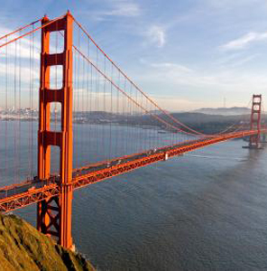

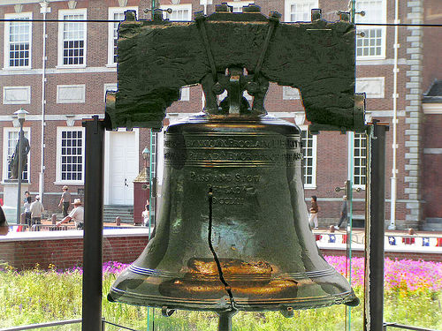

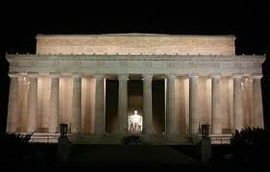

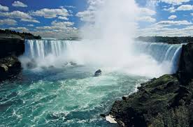

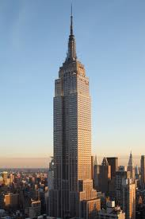

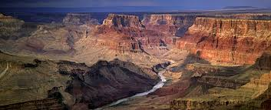

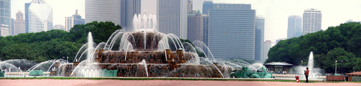

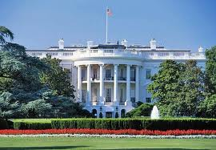

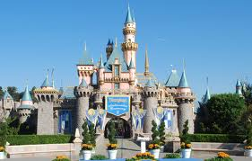

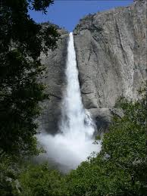
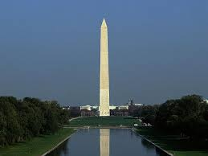

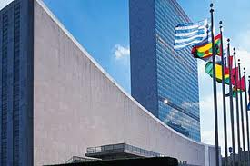

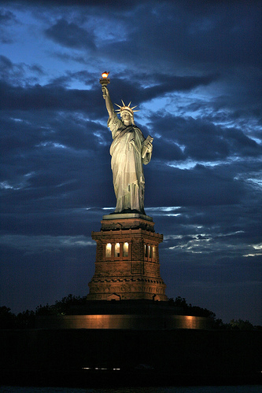

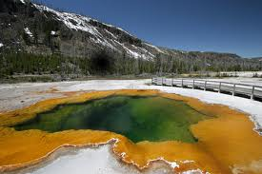

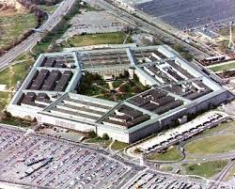

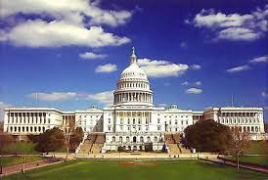
Station 5 People of the USA
- Who was the first American on the Moon? (Neil Armstrong, July 20, 1969, space system “Apollo”)
- Who of American presidents had a nickname “Honest Abe”? (Abraham Lincoln)
- Who was the “King of Rock and Roll”? (Elvis Presley)
- What was Mark Twain’s real name? (Samuel Clemens)
- Who invented the modern detective story? (Edgar Poe)
- Who invented the telephone? (Alexander Bell)
- Who invented the coca – cola? (John Pemberton)
- Who was the leader of the American army in the Revolutionary War? (George Washington)
- What famous American singers do you know? (Louis Armstrong, Elvis Presley, Madonna, Michael Jackson)
- Who made the first American flag? (Betsy Ross)
- Who wrote the song “That’s all right , Mama”? (Elvis Presley)
- Who is the President of the USA? (Barack Obama)
- Who built the first car? (Henry Ford)
- Who fought against racial discrimination in the 1960s? (Martin Luther King)
- Who wrote a large part of the Declaration of Independence? (Thomas Jefferson)
- Who wrote the novel “Gone with the Wind”? (Margaret Mitchel)
- Who invented the soft drink Coca- Cola? (John Pemberton)
- Who was the first American President? (George Washington)
- Who played the role of Rhett Butler in the screen version of the novel “Gone with the Wind”? (Clark Gable)
- Who created Donald Duck? (Walt Disney)
- Who is regarded as the most successful director in Hollywood today? (Stephen Spielberg)
- Who created “The Adventures of Tom Sawyer”? (Mark Twain)
- Who was the youngest American President? (John Kennedy)
- Who invented the light bulb? (Thomas Alva Edison)
- Who wrote the Emancipation Proclamation? (Abraham Lincoln)

Station 6 Holidays and traditions of the USA
- When is Independence Day celebrated? (on the 4th of July)
- Name the national holidays. (New Year’s Day, Christmas, Independence Day, Labour Day, Thanksgiving Day)
- When is the Election Day? (in the month of November on the first Tuesday after the first Monday)
- What holiday do American people celebrate on the fourth Thursday in November? (Thanksgiving Day)
- When do American children dress up in costumes, go from house and say: “Trick or treat!” (Halloween)
- What food is traditional at Easter? (eggs, Easter Rabbit)
- Why do American children hang up their stockings on Christmas Eve? (They believe that Santa Claus comes with a big bag of toys)
- What is the national sport in the USA? (baseball)
- What do Americans have when some families get together? (Potluck supper)
- What other holidays are celebrated in the USA? (Groundhog Day, Martin Luther King’s Day, St. Valentine’s Day, President’s Day, St. Patrick’s Day, All Fools Day, Mother’s Day, Flag Day, Father’s Day, Columbus Day, Veteran’s Day, Memorial Day, Election Day)

Station 7 Symbols of the USA
- What is the number of the stars on the American Flag? (50)
- How is the American Flag called? (The Stars and the Stripes)
- What are the national symbols of the USA? (the Declaration of Independence, the Liberty Bell, the Statue of Liberty, the American eagle, the donkey and the elephant, Uncle Sam)
- What are other names of the USA national flag? (“The Stars and Stripes” – is the most popular. “Star Spangled Banner” Francis Scott Key, 1814, “Old Glory” – William Driver, 1824)
- What do 13 red and white stripes mean? (original colonies, which declared their independence from Great Britain)
- What do colours of the American Flag symbolize? (Red colour is for courage. White is for purity. Blue is for justice.)
- What is the National Anthem of the USA? (It is called “Star –Spangled Banner”)
- What is the history of the National Anthem of the USA? (It was written by the lawyer Francis Scott Key in 1814. Congress adopted it as the national anthem in 1931)
- What is the national motto of the USA? (“In God We Trust.” It was adopted in 1956. You can see these words on all American paper bills.)
- What do the stars on the American flag stand for? (50 states)
- What is the main figure in the emblem of the USA? (eagle )
- Which country gave the Statue of Liberty to America? (France, 1884)
- What is the national symbol of the USA? (the bald eagle)
- What’s American symbol of Freedom? (the Statue of Liberty)
- What is the symbol of the Republican Party? (the Elephant)
- What is the symbol of the Democratic Party? (the Donkey)
- How many stripes were there on the American flag originally? (13)
- How many stars were there on the American flag originally? (13)
- How many stripes are there on the US flag? (13)

Station 8 Cities of the USA
- The island in the centre of New York is called … (Manhattan)
- What is the capital of the USA? (Washington)
- What is the city where the Golden Gate is situated? (San Francisco)
- New York is called … (“the Big Apple”)
- What is the largest city? (New York)
- In which city is Hollywood situated? (Los Angeles)
- What was the first name of New York? (New Amsterdam)
- What city is called “the Paris of the West”? ( San Francisco)
- What are five largest cities in the USA? (Los Angeles, New York, Dallas, Chicago, Philadelphia)
- Which Californian city was destroyed by an earthquake? (San Francisco)
- What city is called “Windy City”? (Chicago)
- What is the capital of Massachusetts? (Boston)
- What is the capital of Georgia? (Atlanta)
- What is the second largest city in New York State? (Buffalo)
- What is the fourth largest city in the USA? (Philadelphia)
- What city is a world’s famous resort? (Miami)
- What is the full name of Los Angeles? (The town of Our Lady the Queen of the Angels)
- What is the nation’s second largest city? (Chicago)
- What is the population of New York? (8 mln people)
- How many district does New York City consist? (5)
- What is the nickname of San Francisco? (The Paris of the West)
- What is the capital of Alaska? (Juneau)
- What is the capital of Florida? (Tallahassee)
- The cowboy capital of the world is… (Dodge City)
- The capital of Oregon is … (Salem)

Station 9 Education and Science
- When was Harvard College founded? (1636)
- How many elementary schools are there in the USA? (77000)
- How many high schools are there in the USA? (23000)
- How many colleges and universities are there in the USA? (3500)
- What do local high schools offer to reflect students needs (courses)
- How does the school age vary? (from 6 to 18)
- What is the American high school? (It’s a combination of all the types of schools)
- What are free schools? (They give students more freedom how and what to study)
- How many tests are there for students who wish to attend a college or university? (2)
- What are they? (SAT, ACT)
- Who wrote the first American book? (Captain John Smith)
- Who invented the telephone? (Alexander Bell)
- Who invented the telegraph? (Samuel Morse)
- When did the Garret Morgan invent the traffic light? (1916)
- Who made the artificial heart? (Robert Jarvik)
- When did Chester Carlson invent a machine to make Xerox copies? (1938)
- Who invented bifocal lenses for eyeglasses? (Benjamin Franklin)
- When did Charles and Frank Duryea invent the first gasoline automobile? (1892)
- When did Nolan Bushnell invent Video Game? (1972)
- When did George Eastman produce the Kodak camera? (1888)

- Summing-up
- Let’s sum up the results of our trip. Our game is over. The final score is … in favour of the team.
What have we done at the lesson? Did you like this lesson? Have you found new information?
Your marks are..
Thank you very much for our cooperation. I hope that our lesson will help you in future and you will visit the USA. Maybe, our dreams come true one day.
- Home Assignment

- Our lesson comes to the end and your home assignment will be to prepare the report about the famous sights of the USA.

