Міністерство освіти та науки України
Відділ освіти Ленінської в місті Донецьку ради
Багатопрофільний ліцей № 37

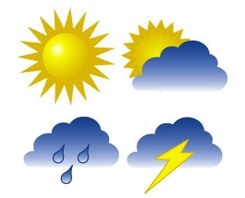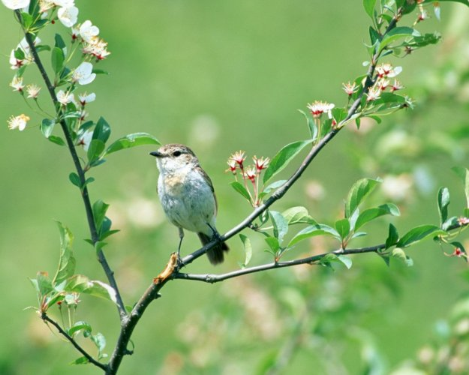

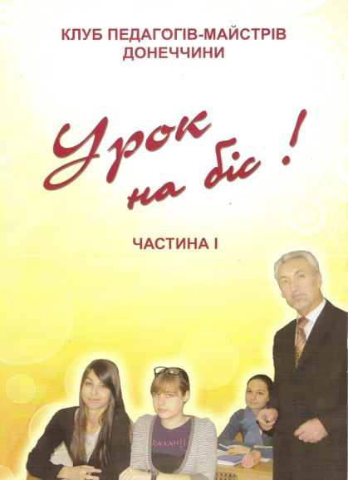
Роботу надруковано у збірнику «Урок на біс!»
Клуб педагогів-майстрів Донеччини.
Управління освіти і науки Донецької облдержадміністрації.
ОблІППО
Донецьк. Витоки. 2011.

Учитель англійської мови Жигло Ірина Вікторівна.
2010-2011 н.р.

РОЗРОБКА УРОКУ З АНГЛІЙСЬКОЇ МОВИ ЗА ТЕМОЮ «ПРИРОДА. ПОРИ РОКУ. ПОГОДА.» В 5 КЛАСІ З ВИКОРИСТАННЯМ МУЛЬТИМЕДІЙНОГО ОБЛАДНАННЯ ТА ІНТЕРНЕТУ ON-LINE.

Жигло Ірина Вікторівна, вчитель англійської мови вищої категорії багатопрофільного ліцею № 37 міста Донецька, вчитель-методист, керівник методичного об’єднання вчителів іноземних мов ліцею, переможець районного туру конкурсу Вчитель року 2008.

Тема: Природа .
Підтема : Пори року. Погода.
Цілі:
Практична: розвивати вміння читати та аудіювати тексти, ігноруючи незнайомі слова.
Освітня: розширити знання учнів про таке граматичне явище, як теперішній неозначений час.
Розвиваюча: розвивати вміння робити усні та письмові повідомлення про явища природи, використовуючи зорові опори.
Виховна: прищеплювати любов до природи, викликати інтерес до природних явищ та бажання вивчати їх. Формувати командний дух.
Обладнання: персональний комп’ютер, мультимедійний проектор, екран, Інтернет-сторінки British Council [http://www.britishcouncil.org/kids], Starfall [http://www.starfall.com/], роздатковий матеріал-картки, таблиці для перевірки розуміння текстів читання та аудіювання, а також для відпрацювання лексичного та граматичного матеріалу, кольорові флеш-картки із сайту [http://www.britishcouncil.org/kids-flashcards-weather-1.pdf], роздруковані заздалегідь, авторська презентація Microsoft Power Point “The Seasons in England”.

Хід уроку.
- Підготовка до сприйняття іншомовного мовлення.
- Привітання і повідомлення теми та мети уроку.
Dear pupils. I am glad to see you here. I am sure you are ready for active work. Our topic today is “Nature. Seasons and Weather”. By the end of the lesson you should learn more about nature, seasons of the year, the weather in England and Ukraine, you have also learn how the weather forecast is made and other things. So let’s start our class with one of our favourite songs from the British Council Internet site.
- Уведення в іншомовну атмосферу.
1) (Учні дивляться на екран та співають пісню) [http://www.britishcouncil.org/kids-songs-seasons-lyrics.pdf] [http://www.britishcouncil.org/kids-songs-seasons.htm]
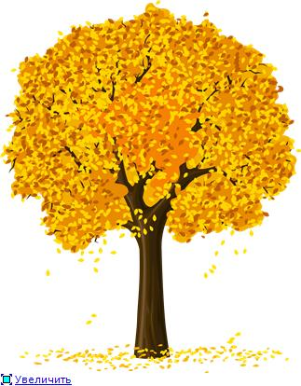
The Four Seasons.
The leaves on the trees are turning green
Turning green, turning green.
The leaves on the trees are turning green
Grow, grow, grow!
The flowers on the trees are beautiful
Beautiful, beautiful.
The flowers on the trees are beautiful
Busy busy bees.
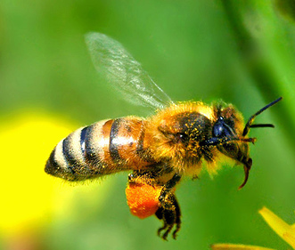
The leaves on the trees are falling down,
Falling down, falling down
The leaves on the trees are falling down
Yellow, red and brown.
The leaves on the trees have fallen down,
Fallen down, fallen down.
The leaves on the trees have fallen down
All on the ground.
- Let’s make a calendar. [Starfall http://www.starfall.com/n/holiday/calendar/play.htm?f]
Учні складають календар за допомогою інтернет-сторінки Starfall, яка оновлюється кожного дня, повторюють дні тижня, місяці року та записують у зошити день тижня та дату.
- Phonetic warm up. Tongue twister. [http://www.starfall.com/n/twisters/shellysells/load.htm?f]
Train the sounds [∫] and [s]. Compare them.
She sells seashells by the seashore.
II. Основна частина уроку.
- Practice topic words.
- Find the weather words.
Sunnydgwindytkrainyvfstormydcloudybnhotgwarmvcoldcfoggynsnowyjweather

- Weather in UK. Match the weather to the seasons. [http://www.britishcouncil.org/kids-print-weather-words.pdf]
Робота з флеш-картами інтернет-сторінки British Council. (роздатковий матеріал)
winter
autumn
spring
summer

It’s very cold and it snows. Christmas is in this season.
It’s rainy and wet. Trees and flowers start to grow.

It’s hot and sunny. People go on holiday.
It’s cold and foggy. Trees lose their leaves.

С) One Odd Out.
January | February | - South | May
sun | cloud | rain | to wear
to blow | to fall | vegetables | to shine
season | warm | cool | cold
September | October | November | winter
rain | snow | wind | night

- Reading. (Cупроводжується презентацією Microsoft Power Point).
Pre-reading task.

Put the words into the correct order to make up sentences:
families/English/to/their/like/spend/holidays/the/in/country/

English/is/like/a/the/countryside/of/carpet/flowers/many/

is/snow/in/there/little/winter/England/in/

the/is/English/hot/summer/very/never/

children/much/English/to/very/like/football/play/

Check yourselves:
English families like to spend their holidays in the countryside.
The English countryside is like a carpet of many flowers.
There is little snow in winter in England.
The English summer is never very hot.
English children like to play football very much.

The Seasons in England.
English families like to spend their holidays and the weekends in the countryside. The English countryside is like a carpet of many flowers in every season. In spring and summer the fields, the meadows and the forests are light green and dark green. The gardens are red, blue, yellow and white with flowers. In autumn the leaves on the trees change their colour from green to yellow, brown, red and orange. The English summer is never very hot and in winter it is not very cold. Spring and autumn are cool. Cold wind blows in winter from the sea, in summer the winds are cool. There is little snow in winter, and it never stays on the ground for long. There is little snow in winter, and it never stays on the ground for long. But there is much rain in England all the year round. The weather is very changeable. The grass in the mountains is green all the year round. That’s why you can see many cows and sheep in the meadows. English children like to play football very much. They can play football even in winter because the football fields are always green. All children like summer best of all because it is the season of their holidays. They can go to the seaside, play in green parks and walk in the mountains.
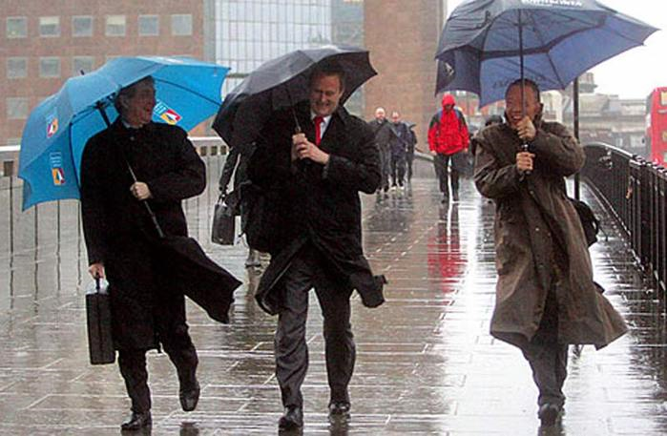
Post-reading task. Choose the correct variant.
- English families like to spend their holidays and the weekends in the countryside/at the seaside.
- Cold wind blows in winter from the sea/from the ocean.
- There is little snow/rain in winter.
- The weather is changeable/fine.
- The grass in the mountains is green all the year round/in summer.
- You can see many cows and sheep in the meadows/in the countryside.

- Grammar. The Present Simple Tense. Writing.
Учні виконують граматичні завдання, контрастуючи третю особу однини та множини.
- Each sentence has a mistake.
Find it and correct it.
- Example:
Where does your sister works? Where does your sister work?
- What do she wear in summer?
- It often snow in winter.
- Canadians lives in the North.
- English children plays football even in winter.
- Cold wind blow in winter from the sea.
- Keys:
- What does she wear in summer?
- It often snows in winter.
- Eskimos live in the North.
- English children play football even in winter.
- Cold wind blows in winter from the sea.
b) Use the words in brackets in a proper form.
Use the words in brackets in a proper form.

It often (to snow) in winter.
The sun (to shine) brightly in summer.
They (to live) in the South.
Little children always (to wash) with warm water.
Ann usually (to wear) bright dresses in spring.
Boys (to play) football in warm seasons on the football field.
It usually (to snow) in winter.

Check yourself.
It often snows in winter.
The sun shines brightly in summer.
They live in the South.
Little children always wash with warm water.
Ann usually wears bright dresses in spring.
Boys play football in warm seasons on the football field.
It usually snows in winter.
- Listening. Weather.
- Pre-listening tasks.
Weather word bank.
1 | state | стан
2 | heat | спека
3 | wetness | вологість
4 | dryness | сухість
5 | calm | затишність
6 | cloudness | хмарність
7 | weatherman | метеоролог
8 | natural features | природні риси
9 | weather station | метеостанція
10 | weather forecast | прогноз погоди
11 | space | космос
12 | collect | збирати

Match the pairs.
1 | state | космос
2 | heat | затишність
3 | wetness | сухість
4 | dryness | вологість
5 | calm | спека
6 | cloudness | збирати
7 | weatherman | природні риси
8 | natural features | метеоролог
9 | weather station | прогноз погоди
10 | weather forecast | метеостанція
11 | space | стан
12 | collect | хмарність

Weather is a part of nature. Weather is the state of the atmosphere at a particular place during a short period of time: heat or cold, wetness ot dryness, calm or storm, clearness or cloudness. Weathermen study natural features. They collect information from ships, planes weather stations and space stations. So they can understand what the weather will be like during the next few days. Then they make a weather forecast. With the help of weathermen we know what clothes to choose for the day.

The weather forecast.
Good evening! And here is the weather forecast for tomorrow. In the Western Ukraine it will be cold with snow in the mountains. In the north of Ukraine it will be a wet day with rainstorms that will move to the east during the afternoon. The weather in the centre of Ukraine will be dry but cloudy. In the south of Ukraine the day will be bright and clear with a lot of sunshine but it may be windy in the evening. And now -about the weather in details in each region of Ukraine.
Post listening task.
Teacher: At home you were to find the information about the weather forecast in one of the regions of Ukraine. You were to use photos and pictures. You did your best and prepared good projects. We displayed them on the magnet board. Now it’s time to present your projects.
Regions of Ukraine.
Cherkasy | Kirovohrad | Sumy
Chernivtsi | Kyiv | Ternopil
Chernihiv | Luhansk | Vinnytsia
Dnipropetrovsk | Lviv | Volyn
Donetsk | Mykolaiv | Zakarpattia
Ivano-Frankivsk | Odesa | Zaporizhzhia
Kharkiv | Poltava | Zhytomyr
Khmelnytskyi | Rivne | Crimea

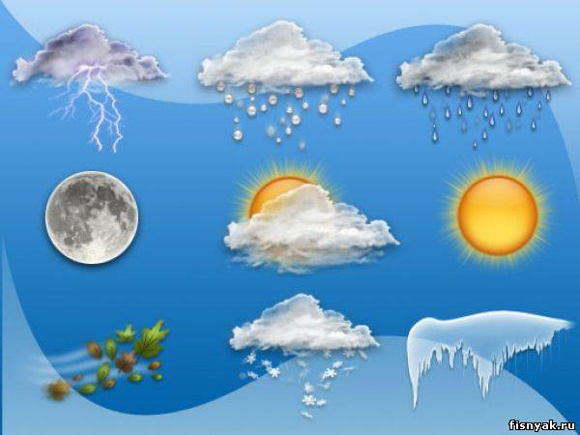
Учні презентують свої проекти, які розміщені на магнітній дошці та проектуються на екран.
- The Weather Forecast in Donetsk. (An example of a project work)
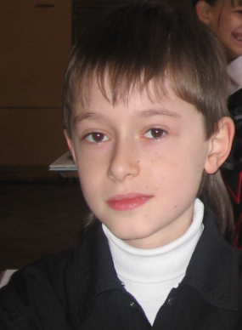
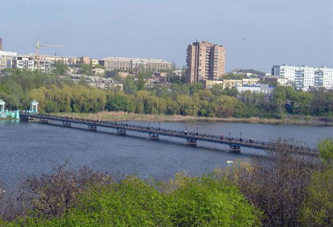
Vova Gorovoy, the correspondent of the school newspaper “English Bridge”. Donetsk.
Good evening! And now it’s time for weather forecast with Vladimir for tomorrow, Tuesday, the 1st of December in Donetsk and its region. It will be cool but sunny. The day will be bright and clear. It may be windy in the afternoon. The temperature will be about 8 degrees above zero.
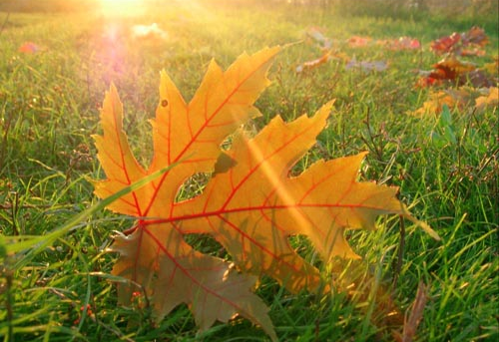
In the western part of Donetsk region it will be a wet rainy day. Rains will move to the east of the region in the evening. Don’t forget to take umbrellas and put on your warm clothes.


[From Internet recourses, pictures- http://images.yandex.ua/]
- Team work. Гра “Guess what season it is.” Speaking.
Учні поділяються на 4 команди. Кожна команда отримує картки з описом однієї пори року. Команди опрацьовують свій текст, готують питання для інших команд, потім презентують свою пору року. Вони відповідають на питання представників інших команд, які намагаються здогадатись, яка це пора року. Перемагає та команда, яка перша дала вірну відповідь.
Зразки питань:
- Are the days long or short?
- Do the birds come back from the South or fly away?
- What is the weather like?
- Is it warm or cool? Is it cold or hot?
- What can we see in the parks and squares?
- Are there leaves in the trees?
- What colour are they?
- Do they fall from the trees?
- Does it rain or snow?
- Are there clouds in the sky?
- What colour is the sky?
- What clothes do people wear?
- Are there fruit and vegetables?
- Can children bathe in the river or swim in the sea?
- Do children ski, skate or sledge?
Тексти для команд.
Spring.
Spring comes after winter. March, April and May are spring months. In spring the days are long and the nights are short. The birds come back from the South. In March it sometimes snows but in the South we can see the green leaves in the trees and the first flower in the fields. In April and May it is warm. The weather is fine. The sun shines brightly in the blue sky. We can see many beautiful flowers in the parks, gardens and squares. In spring people do not wear warm coats and hats.
Summer.
Summer comes after spring. June, July and August are summer months. In summer the weather is fine. The sun shines brightly in the blue sky. It is hot. The trees are green. The flowers in the parks and garden are white, yellow, blue and red. The days in summer are long and nights are short. In summer people usually wear summer suits and dresses. All the children like summer very much because they have they the longest holidays. In hot summer days they can bathe in the river or in the sea and lie in the sun.
Autumn.
Autumn comes after summer. September, October and November are autumn months. It is cool in autumn. The weather sometimes isn’t fine. The sky is grey. There are clouds in the sky. It often rains and the wind blows. The leaves in the trees are yellow and red. They fall from the trees. The days in autumn are short and it often rains. There is much fruit and vegetables in autumn.
Winter.
Winter comes after autumn. December, January and February are winter months. In winter the weather is frosty. It is very cold. It often snows. There are no leaves in the trees. The streets, the trees and the fields are white with snow. The days are short and the nights are long. In winter people usually wear warm coats and hats. In January children have their winter holidays. In frosty snow weather we can see many children in the parks, gardens and stating rinks. The ski, skate, sledge, play snowballs and make snowmen. Winter is a very nice season. Many people like winter very much.
Teacher sums up:
Quiz. What season is it?
- The weather is fine. The sun shines brightly in the blue sky. It is hot. The days are long and the nights are short. There are many flowers in the parks and gardens. Children like this season very much. (summer)
- The sky is blue. The birds come back from the South and sing songs. You can see first green leaves and green grass. It is warm. The weather is usually fine. (spring)
- It snows and it is cold. The nights are long and the days are short. Children can skate and sledge. They make snowmen. People celebrate one of the best holidays of the year. They buy and decorate fir-trees. They give each other presents.(winter)
- The sky is grey. It often rains. The leaves on the trees are yellow, red and brown. The birds fly away to the South. The sun doesn’t shine brightly. (autumn)
3  4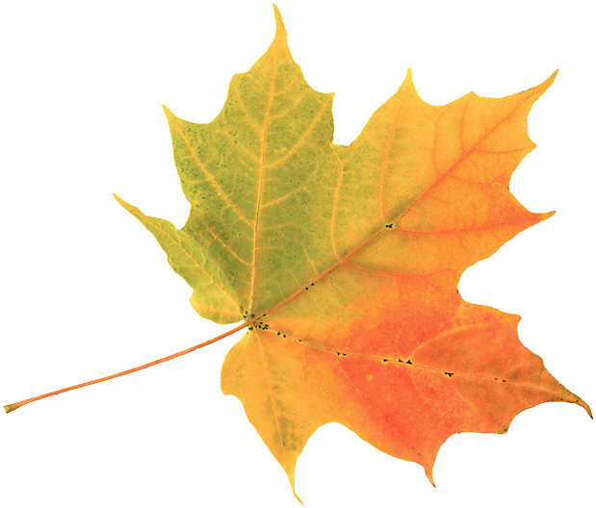 2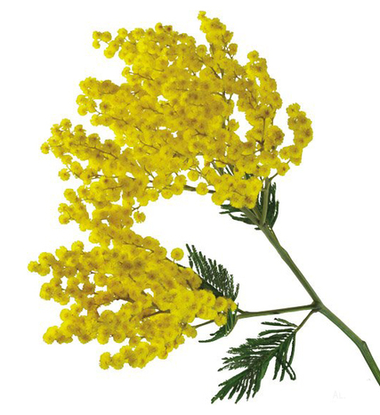 1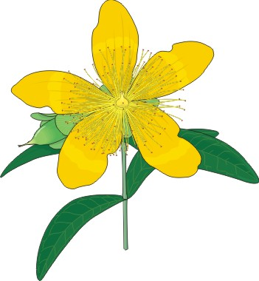

III. Заключна частина уроку.
- Підсумки уроку. Dear friends! Our lesson is coming to an end. It’s time to say good-bye. We’ve done much at the lesson. We read, listened to the text, did exercises on the texts, you sang songs you presented your projects. You were great! You all get good and excellent marks. Your home task for the next lesson is to speak about one of the season of the year.
- Учні співають пісню “Time for another year” [http://www.britishcouncil.org/kids-songs-months-lyrics.pdf][ http://www.britishcouncil.org/kids-songs-months-2.htm]
January, February, March
April, May and June
July and August, goodbye summer
Autumn’s coming soon
Hey September, October, November
It’s December, winter’s here
Goodbye Christmas, that’s the end
Time for another year. (Twice)

Література.
Бондарь М. В., Карась Л.В. Англійська мова. 7 клас. Плани-конспекти уроків. Харків. Видавництво «Ранок» «Веста» 2001.
Плахотнік В. М., Мартинова Р.Ю. Англійска мова 7 клас. Київ, Освіта,2001.
Сірик Т.Л., Сірик С. В. English 8 (4). Видавництво «СТЛ-книга» Полтава, 2008.
Крамаренко Л.В. Збірник текстів для аудіювання в 5-11 класах загальноосвітніх шкіл. Харків. Видавництво «Ранок» «Веста» 2003.
Reference Guide for the Teacher of English. Київ. «Редакції загальнопедагогічних газет» 2004.

