Where do you live?
I live in a city.
I live in a village.
I live
They live
He lives
She lives
on the left

on the right


This is the plan of the house. It has got a hall, a bedroom, a living-room, a kitchen and a bathroom.

The kitchen is on the right. The living-room is on the left. The bathroom is on the right. The bedroom is on the left. A small room is the hall.

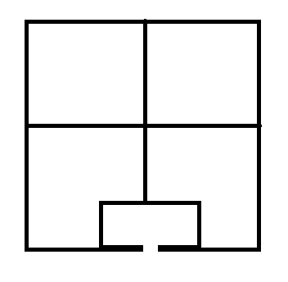

My House
I have got a_________, a ________, a ….
The kitchen is on the …..
The bedroom is on the…..
The living-room is on the ….
The bathroom is on the …

 He is from the USA


She is from Russia

 She is from Japan

 He is from The UK


They are from Ukraine

