Тиждень англійської мови у 1-4 класах.
Тема: «Seasons and Holidays»
Мета проведення тижня англійської мови:
- вдосконалення мовленнєвих та мовних навичок;
- розвиток комунікативних навичок під час підготовки та проведення тижня;
- формування норм поведінки;
- формування морально-етичних норм;
- підвищення інтересу до предмета;
- виховання почуття відповідальності, патріотизму, ставлення до загальнолюдських цінностей.
Тиждень англійської мови у школі-це не тільки звіт про виконану індивідуальну або групову роботу, це свято англійської мови, в якому беруть участь всі учні школи. Однак для кожної вікової групи початкової школи обираються заходи, цікаві для даного віку відповідно до мовної програми. Безумовно, вони відрізняються не тільки мовним оформленням, але і формою проведення, тривалістю, складністю змісту.
Настрій свята, мовна атмосфера створюються за допомогою музики та пісень англійською мовою, присутністю іноземних гостей, кольоровим оформленням стіннівок, виставок, конкурсів, переглядом відеофільмів та проведенням презентацій – тобто кожен день Тижня заповнений іноземною мовою.
Під час планування Тижня англійської мови вчителі враховують можливості своєї школи в цілому, а також рівень знань та вмінь учнів з іноземної мови.

Понеділок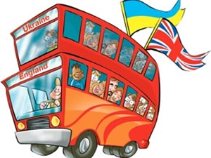
Відкриття тижня англійської мови
« Holidays are great”
Вівторок
Презентація стіннівок
« Around the English - Speaking Countries”

Середа
Пізнавальна вікторина « It is interesting to know” 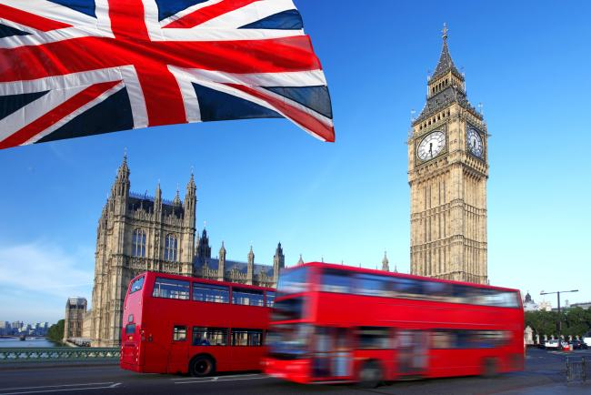
Четвер
Конкурс малюнків« My favourite Holidays”
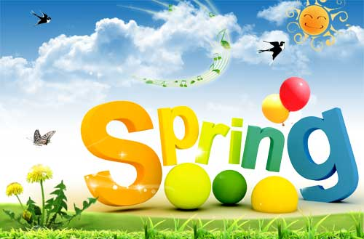
П’ятниця
Конкурс пісень « We wait for holidays”
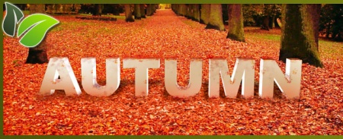
Понеділок 
Підведення підсумків
Костюмований бал. Святкова вечірка
« English holidays”

Пізнавальна вікторина “Around the English-speaking countries”

THE UNITED KINGDOM OF GREAT BRITAIN
AND NORTHERN IRELAND
1. Where is the United Kingdom situated?
2. What countries does it consist of?
3. What is the highest mountain on the British Isles?
4. What is the longest river?
5. What is the population of the United Kingdom?
6. How many people live in London?
7. What is the flag of the United Kingdom called?
THE UNITED STATES OF AMERICA
8. Where is the USA situated?
9. What mountains are there in the country?
10. What are the main rivers?
11. What is the population of the USA?
12. How many states are there in the USA?
13. Who is the head of the state?
14. What is the capital of the USA?

CANADA

15. What is the capital of Canada?
16. What is the population of Canada?
17. What are the most important cities?
18. What are the largest lakes in Canada?
19. What mountains are there in Canada?
20. What are the longest rivers?

AUSTRALIA

21. What is the capital of Australia?
22. What is the population of Australia?
23. What are the biggest cities in Australia?
24. What are the longest rivers?
25. What mountains are there in Australia?
26. What does Australia consist of?

THE UNITED KINGDOM OF GREAT BRITAIN
AND NORTHERN IRELAND
a). Ben Nevis.
b). On the British Isles.
c). The Union Jack.
d). Over 57 million people.
e). England, Scotland, Wales and Northern Ireland.
f). More than 7 million.
g). The Severn.

THE UNITED STATES OF AMERICA
h). The president
i). Washington, D.C.
j). In the central part of the North American Continent.
k). Fifty states.
l). The Mississippi, the Colorado, the Columbia.
m). The Cordillera, the Rocky Mountains, the Appalachian.
n). More than 236 million people.

CANADA
o). The Great Lakes Superior, Huron, Erie and Ontario, Great Bear Lake, Great Slave Lake and Lake Winnipeg.
p). Montreal, Toronto, Edmonton, Hamilton, Winnipeg, Quebec.
q). Ottawa
r). The Mackenzie, Yukon, St. Lawrence River.
s). Over 24 million people.
t). The Rocky Mountains.

AUSTRALIA

u). The Australian Alps, the Blue Mountains.
v). The Murray and the Darling.
w) Six states and two territories.
x). Sydney, Melbourne, Adelaide, Perth, Brisbane.
y). Canberra.
z). About 15 million people.

Проведення свята
Поки учні збираються у залі, грає пісня “ We are the children”
The host:
Hello, dear children. Hello, dear teachers. Hello, dear parents. We are glad to meet you at our party devoted to the English Language Week. We are really happy to have such a great tradition of celebrating the week, so let’s show how we are happy today and let’s recollect all our impressions about virtual travelling to different countries during these holidays.
All the pupils sing and role-play the song“ I’m HAPPY” (the tune B-I-N-G-O)
I’m H-A-P-P-Y
I’m H-A-P-P-Y
I know I am, I’m sure I am
I’m H-A-P-P-Y.
(Every next time of singing the song children clap instead of the letter at the beginning of the word H-A-P-P-Y)
I’m clap-A-P-P-Y
I’m- clap-A-P-P-Y
I know I am, I’m sure I am
I’m clap--A-P-P-Y., etc.
The host:
The countries where we were travelling to had been chosen not accidentally – we visited English-speaking countries. Our pupils were divided into four tourist groups by the forms, and every form was travelling to one English-speaking country. The 1st form visited the UK, the 2nd form visited the USA, the 3rd form went to Canada, the 4th form sailed to Australia. Moreover, they visited these countries on different holidays.
The longest and the most favourite holidays are summer ones, that’s why let’s meet the first form which introduces Summer holidays.
(One pupil recites the poem )
Что вы знаете про лето?
Лето в платьице одето,
В босоножки и в панаму,
На мою похоже маму,
Лето – доброе, как мама,
Лето, лето – это SUMMER.

The host:
In summer the sun usually shines brightly that’s why let’s listen to the poem about the sun.
The summer sun is in the sky,
Shining, shining up so high
Makes it warm for outside fun.
To play at the park and run,
To swim and hike and fish,
And to go on a picnic if you wish.

The host:
So, today the 1st form introduces summer holidays and now the children are ready to show their costumes. Let’s greet them!

While playing the merry music children walk around the Assembly Hall and show their costumes)
The host:
Well done! We’ll be waiting for the next summer holidays thanks to you. Everybody likes summer and likes having a rest during summer holidays, so let’s see how we can rest and what we can do at the park.
( Children of the 1 form sing the song)
Song “At the Park”
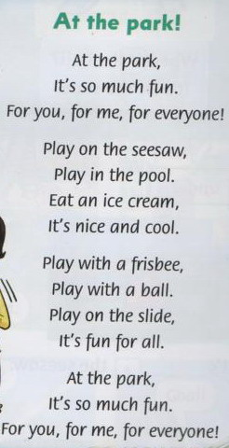

The host:
Our 1st form did a lot of fantastic work during the English – Language Week and they get special diplomas, because almost everyone from the class is a real star.
(The pupils get awards and presents)
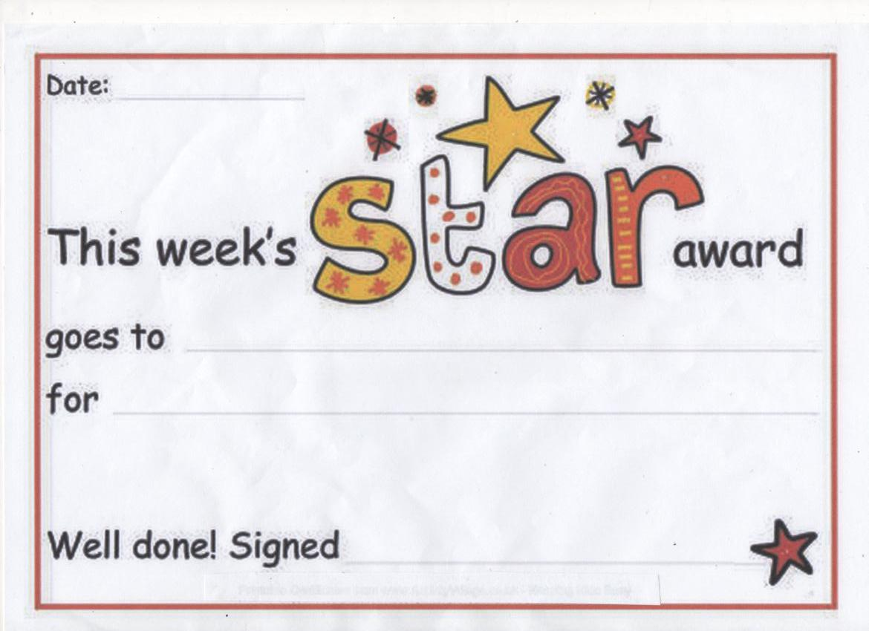

Let’s greet the winners!
Let’s go on further! The 2nd form travelled to the USA on their autumn holidays and they are ready to tell us what they did in autumn.
(The pupil wearing an autumn costume recites a poem)

Poem “ An Autumn Greeting “
"Come," said the Wind to the Leaves one day.
"Come over the meadow and we will play.
Put on your dresses of red and gold.
For summer is gone and the days grow cold."
The host:

Our 2nd form pupils have prepared beautiful costumes of autumn nature. Let’s greet them and enjoy their appearance.
(While playing music children walk around the Assembly Hall and show their costumes)

The host:

So, in autumn it usually rains, but after the rain we can see a rainbow in the sky. Let’s sing a song about the rainbow.
Song “ I can see the Rainbow ”
Red and yellow and pink and green
Purple and orange and blue
I can sing a rainbow,
sing a rainbow,
sing a rainbow too.
Listen with your eyes,
Listen with your ears,
and sing everything you see,
I can sing a rainbow,
sing a rainbow,
sing along with me.
Red and yellow and pink and green,
Purple and orange and blue,
I can sing a rainbow,
sing a rainbow,
sing a rainbow too!

The host:

The pupils of the 2nd form did their best at the English Language Week, so they are awarded by “Happy “diplomas and presents.
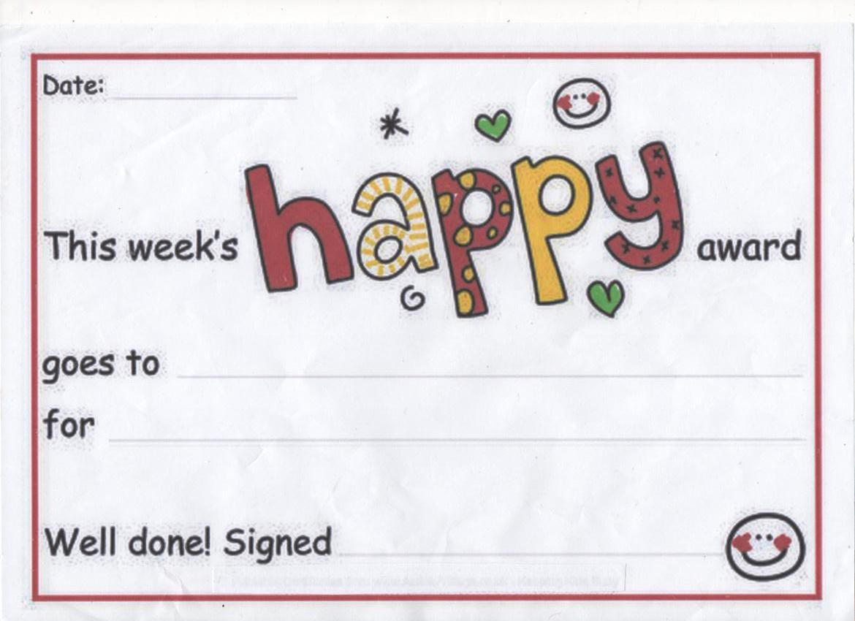

(The pupils are awarded)

And now we will meet the 3rd form that travelled to Canada on their winter holidays. Canada is an amazing country and everybody wishes to visit it especially in winter.
(Four pupils recite the poem in turn)

Here comes winter, cold and grey.
The hedgehog tucks itself away.

Here comes ice and here comes snow.
It needs somewhere warm to go.

Here comes mist and freezing fog.
Here's a good old hollow log.

And here's a pile of leaves that's deep.
It rolls up tight and goes to sleep.

The host:

So, let’s see what the children like doing during their winter holidays – let’s enjoy their costumes.
(The 3rd form pupils walk around presenting their costumes while playing the music))

The host
Our 3rd form is really very friendly and they like having a rest together. Let’s sing the song about their free time.

Song “ I Like Coffee! “

I like coffee, I like tea,
I like swimming in the sea!
I like ice cream, I like cake,
I like sailing on the lake!
I like Elvis, I like Sting,
I like gardening in the spring!
I like English, I like school,
I like sitting by the pool!

The host:
As you see, the children did great work and they are awarded by special diplomas and presents.
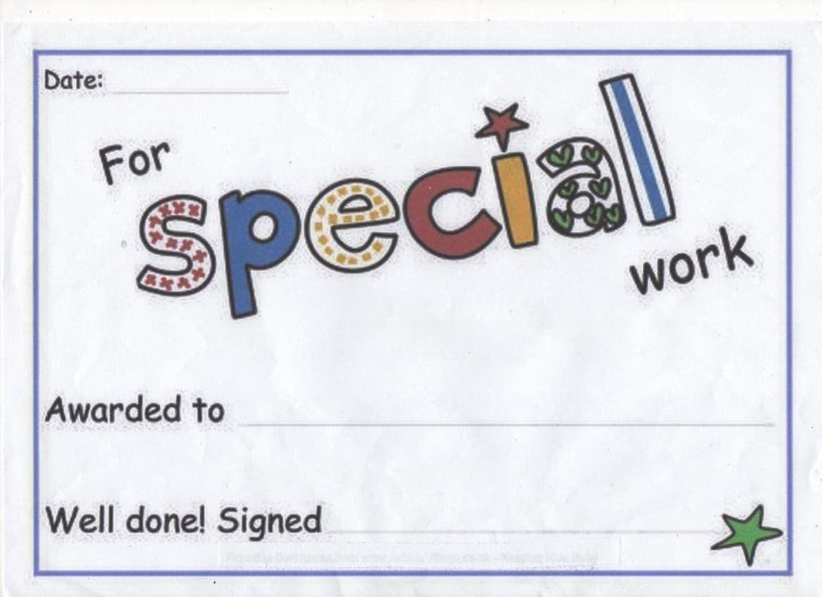

And at last, our 4th form pupils visited Australia during their spring holidays and they are looking forward to the next coming of spring, because they like spring very much.
( Four pupils recite the poems wearing the costumes of spring flowers)

You can tell it's spring
When the trees turn green
And there are just puddlies
Where the snow has been.

You can tell it's spring
When the birds build nests
And mum packs away
Our warm winter vests.

You can tell it's spring
When the yellow heads
Of daffodils dance
In the flower beds.

You can tell it's spring.
It's lighter each day
And after school
We can stay out and play.

The host:

The pupils have prepared nice costumes of spring features and they are ready to introduce them to you.

(The 4th form pupils walk around presenting their costumes while playing the music)
The host
Spring is the time of love and happiness. Let’s sing the song about it.

Song "You Are My Sunshine"

You are my sunshine, my only sunshine
You make me happy when skies are grey
You never know, dear, how much I love you
Please don't take my sunshine away
The other night, dear, as I lay sleeping
I dreamt I held you in my arms
When I awoke, dear, I was mistaken
So I hung my head, and I cried
You are my sunshine, my only sunshine
You make me happy when skies are grey
You never know, dear, how much I love you
Please don't take my sunshine away
The host:

So, the pupils of the 4th form worked very hard during the week, they are awarded by special diplomas “You are special” and presents.
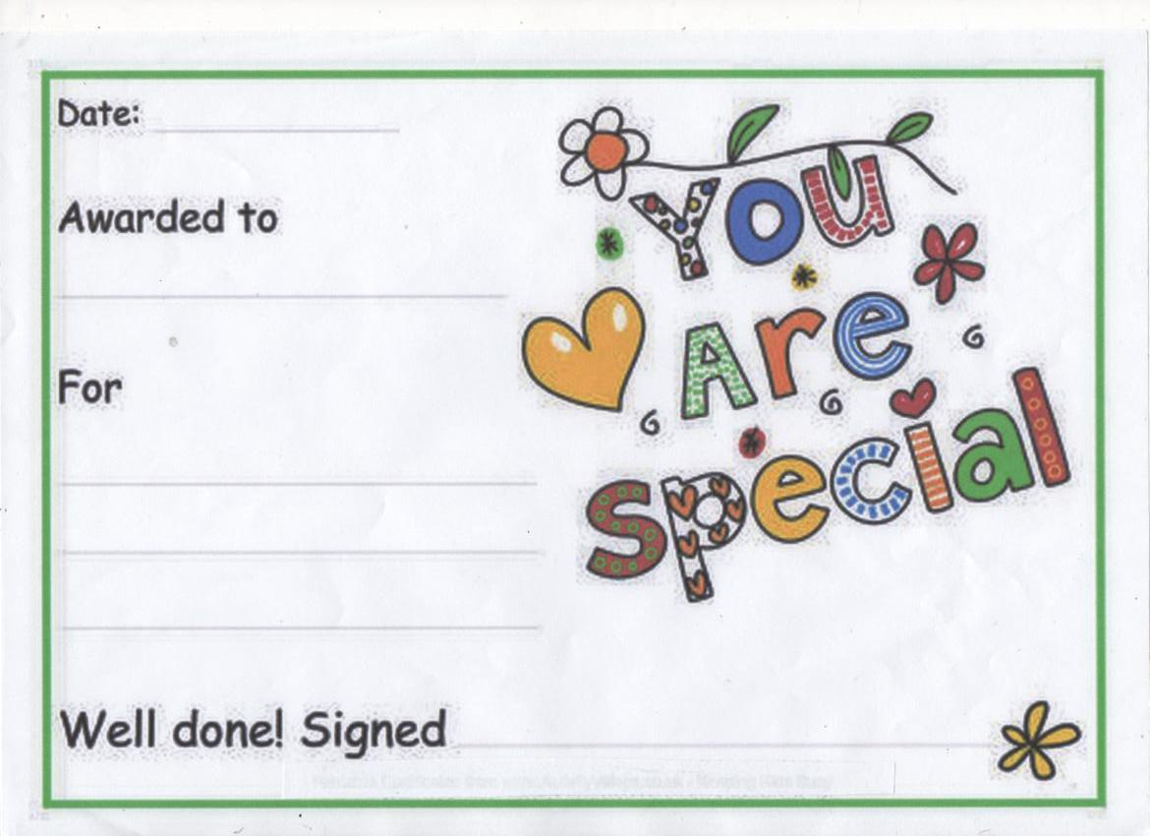
(The pupils are awarded)

The host:
And finally, I’d like to say some words about the winners of the quiz about the English Speaking countries which was held in 3rd and 4th forms. They are awarded by special diplomas.

So, at the end of our party let’s greet one another again by singing the song “ If you’re happy”.

Song “If you’re happy”
If you’re happy and you know it –Clap your hands
If you’re happy and you know it –Clap your hands
If you’re happy and you know it
Then you really are to show it
If you’re happy and you know it –Clap your hands.

If you’re happy and you know it –Stamp your feet
If you’re happy and you know it –Stamp your feet
If you’re happy and you know it
Then you really are to show it
If you’re happy and you know it –Stamp your feet

If you’re happy and you know it –Shout “HOORAY”
If you’re happy and you know it – Shout “HOORAY”
If you’re happy and you know it
Then you really are to show it
If you’re happy and you know it – Shout “HOORAY”
If you’re happy and you know it –Do all three
If you’re happy and you know it – Do all three
If you’re happy and you know it
Then you really are to show it
If you’re happy and you know it – Do all three

