Tests
………........ …………...…
Form 5-….
School №…….

Done by Tokar Oksana Volodymyrivna

Test 1 Module 1 Date________________________________________ Mark _______
Vocabulary
- Complete the ‘communication’ words with the letters A E I O U.
I send C A R D S.
1. We use the __ N T__R N __T.
2. I use my H __ M__ P H__ N __.
3. My sister sends __-M __ __ LS.
4. My brother sends T __ X T M __ S S __ G __ S.
5. We don’t write L __ T T __ R S.
6. My sister sends __ - G R __ __ T __ N G S.
2. Complete the sentences with the correct prepositions.
I get ______up_______ at 7.30.
1. Are you interested _______________ sport?
2. I get ________ ________ Sue and her sister really well.
We’re good friends.
3. He goes _______________ the cinema every week.
4. Maria looks _______________ my cat in the holidays.
5. I’m not very good _______________ maths.
6. Just a minute! Wait __________ me!
Grammar
- Order the words to make sentences.
the / on / I / chat / Net / never I never chat on the Net.
- my / use / mobile / often / I
__________________________________________________

- Saturdays / tennis / usually / they / don’t / on / play
__________________________________________________
- abroad / my / works / sometimes / father

__________________________________________________
- you / watch / do / TV / the / in / always / evening?
__________________________________________________
- phones / never / he / me
__________________________________________________
6. buy / don’t / I / a / usually / newspaper
__________________________________________________

- Complete the sentences with the correct form of the Present Simple.
Tim _doesn’t play_ chess. (not play)

1 I _______________ photography. (like)
2 Where _____________________ ? (Sam / work)
3 How many languages _______________ ? (you / speak)
4 Sue _______________ in London. (not live)
5 _______________ to work by bus ? (they / go)
6 They _______________ their friends at weekends. (meet)
Communication
- Complete the conversation with these words. There is one extra word.
at / don’t / hate /love/ like / love / really /favourite/stand
A: Do you __like ___ making things?
B: Yes, I do. I 1 __________ making models but I’m not very good 2 __________ it. And you?
A: I can’t 3 __________ making models but I 4 __________ mind designing and making clothes. I’m 5 __________ into fashion.
A: Do you _____like _____ art?
B: Yes, it’s my 6 _______________ subject. I 7 _______________ drawing and painting. And you?

- Match the questions (1–5) with the answers (a–e).
What are your hobbies? (f) (a) No, she’s American.
1 Do you get on well with Pete? ____ (b) Yes, I love it.
2 How often do you play chess? ____ (c) Yes, we’re good friends.
3 What’s the London underground (d) Never.
railway called? ____
4 Is your friend English? ____ (e) The Tube.
5 Are you interested in science? ____ (f) Sport and photography

Vocabulary________
Grammar_________
Communication ________
Test 2 Module 2 Date________________________________________ Mark _______
Vocabulary
1. Find five more food and drink words in the word square. 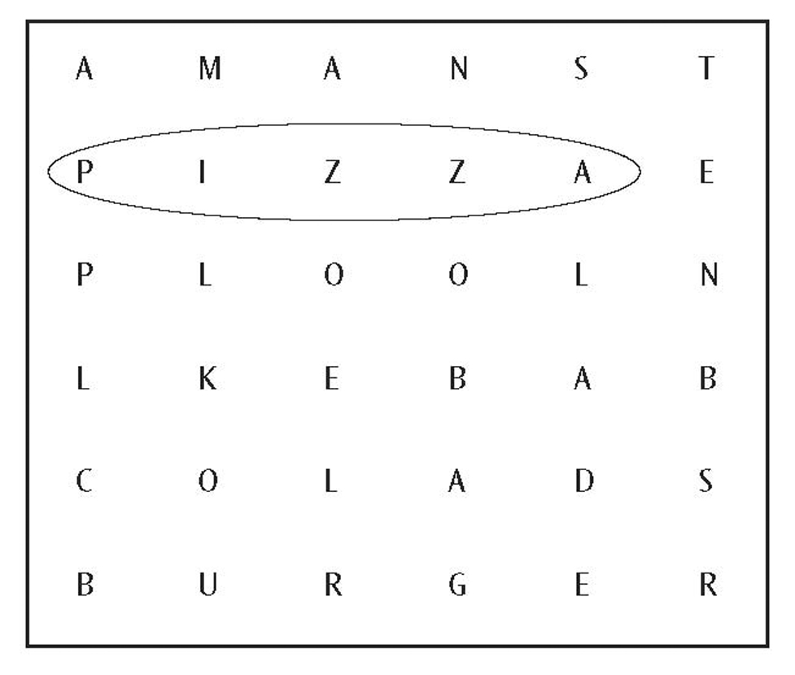
1.......................... 2............................. 3........................ 4........................ 5.............................
2. Complete the sentences with these words.
and / because / rides/but / so / so / shower/ too
Ann didn’t have any breakfast so she’s hungry now.
1 John likes cheese _______________ his sister hates it.
2 She’s a great singer _______________ a good dancer.
3 I’m studying hard _______________ I have my exams this week.
4 I’m into computer games. My friends like computer games, _______________.
5 The children are on holiday this week _______________ they’re very happy.
6 We usually have some very exciting _______________ at the amusement park.
7 Do you always have a _______________ before breakfast?
Grammar
3. Complete the sentences with a, an, the or nothing (–).
My aunt isn’t well. She’s in ___(–) ___ hospital.
My cousins live in 1 __________ old house in 2 __________ interesting village in Ireland. 3 __________ house has got 4 __________ big garden. They’ve got 5 __________ very friendly dog. 6 __________ dog is called Blackie. My cousins go to 7 __________ school by 8 __________ bus. 9 __________ bus driver is their uncle Jim. Uncle Jim is 10 __________ good bus driver.
4. Read the sentences. Circle the correct verb forms.
Are you liking / Do you like pizza?
1 Look! My brother is riding / rides his bike in the garden.
2 They are usually drinking / usually drink milk.
3 What is your mother doing / does your mother do? She’s a teacher.
5. Complete the sentences with the correct form of the Present Continuous.
Tony: Hi, Mark. It’s Tony. What _are you doing_ at the moment? (you / do)
Mark: Hi, Tony. I 1 _______________ (do) my homework.
2 _______________ (you / study), too?
Tony: No, I’m in the kitchen. My sister and I 3 _______________ (prepare) a meal for this evening. We 4 _______________ (make) vegetable curry. It’s mum’s birthday so she 5 _______________ (not cook) today!

Communication
6. Write the sentences in the correct order.
Café assistant: Hello. Can I help you?
1 Yes, sure. Is that all?
2 Large or small chips?
Customer: 3 Yes, thank you.
4 Small, please. And can I have a cola, please?
5 I’d like chicken nuggets and chips, please.
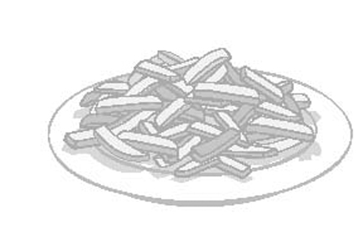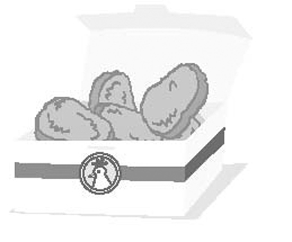
Café assistant: Hello. Can I help you?
Customer: ________________________________________________________________
__________________________________________________________________
Café assistant: ______________________________________________________________
___________________________________________________________________
Customer: _____________________________________________________________
___________________________________________________________________
Café assistant: _____________________________________________________________
___________________________________________________________________
Customer: _______________________________________________________________
______________________________________________________________________

Vocabulary________
Grammar_________
Communication ________

Total________

Test 3 Module 3 Date____________________________________ Mark _______
Vocabulary
1. Complete the words for ‘machines in the home’ with the letters A E I O U.
From the 1950s to the 1980s people played music on a R E C O R D P L A Y E R.
1 Where’s the milk? – It’s in the F R __ D G __ in the kitchen.
2 Put the dirty plates in the D __ S H W __ S H __ R, please.
3 It’s very hot in here. Can we have the __ __ R C __ N D __ T __ __ N __ N G on?
4 What’s that noise? – It’s our old V __ C __ __ M C L __ __ N __ R. My sister is cleaning her bedroom carpet.
5 I’ve got a small T __ L __ V __ S __ __ N in my bedroom. I like watching it when I’m in bed.
2. Complete the sentences with at, in or on.
He arrived ____at____ six o’clock.
1 The town is usually very quiet__________ night.
2 We usually go to Spain __________ the spring.
3 She made her first film __________ 2004.
4 He always plays tennis __________ Saturdays.
5 She passed her driving test __________ 7th September.
3. Complete the table with the correct American English and British English words.
 | American English | British English
 | mom | mum
1 | candy
2 |  | petrol
Grammer
4. Complete the sentences with the correct form of the Past Simple.
A: My grandfather and his parents originally _____came______ (come) from Ireland. His mother and father 1 _______________(buy) a small shop in Liverpool.
B: What 2 _______________ (they / sell)?
A: They 3 _______________ (sell) food, sweets, newspapers, birthday cards, pens – a lot of different things. My grandfather 4 _______________ (not like) school very much. He 5_______________ (leave) school when he was Fourteen. He 6 _______________ (work) hard in his parents’ shop. When he was 23, he 7 _______________ (open) three more shops in Liverpool. When he was 25, he 8 _______________ (fall) in love with a beautiful young woman and they 9 _______________ (get) married. They 10 _______________ (have) two sons and a daughter.
5. Answer the questions using the words in brackets. Write complete sentences.
Why did her mum stay at home? (look after the children)
She stayed at home to look after the children.
1 Why did John go to Hollywood? (make a film)
__________________________________________________
2 Why did Sue come to your house yesterday? (play my new computer games)
__________________________________________________
3 Why did you do a holiday job? (get some money)
__________________________________________________
4 Why did the children stay in the park all afternoon? (play football)
__________________________________________________
5 Why did Mr Smith buy a bike? (cycle to work)
__________________________________________________
6. Order the words to make sentences.
I / the / football / match / to / watch / last / Saturday / decided
I decided to watch the football match last Saturday.
1 to / be / always / wanted / she / an / actress
__________________________________________________
2 when / your / book / write / did / you / start / to ?
__________________________________________________
Communication
7. Complete the description of a photo with these words.
At / in / on / with
This is a photo of some of my family. My mum is the woman _with_ the baby. (The baby is me!). My dad is 1 __________ the left of the picture. He’s the man 2 __________ glasses. My aunt is the woman 3 __________ the white trousers 4 __________ the middle. My two brothers are 5 __________ the front.
8. Match the questions (1–5) with the answers (a–e).
When was Nicole Kidman born? (f) (a) She’s on the left.
1 When did his parents get married? _____ (b) Cookies.
2 What’s the American English word for ‘biscuits’? _____ (c) No, it’s the sixteenth.
3 Where’s your sister in this photo? _____ (d) Eighteen years ago.
4 Is it the fifteenth of April today? _____ (e) He was very popular.
5 What was your dad like at school? _____ (f) In 1967.

Vocabulary________
Grammar_________
Communication ________

Total________
Test 4 Semester test on Listening
Date______________________________________________ Mark__________
Tracks 2-3
1. Listen to the interview with Adam. Tick (✓) the correct answer (A, B or C) for each question.

Example:
0 What is Adam’s family name?
A Waite ✓ B Wait C Wate

1 When is Adam’s birthday?
A tomorrow B next week C next month
2 Where does Adam live?
A New York B London C Dublin
3 What nationality is Adam?
A American B British C Irish
4 What nationality is Adam’s mother?
A American B British C Irish
5 How old is Adam’s mother?
A 40 B 41 C 45
6 What does Adam’s mother do?
A dentist B teacher C electrician
7 How many brothers has Adam got?
A 2 B 3 C 4
8 What doesn’t Adam do?
A sing B play the guitar C play the piano
9 Which sport is he good at?
A tennis B basketball C swimming
10 Which school subject does he hate?
A science B maths C art

2. Listen to a woman ordering food by phone. Complete her order.
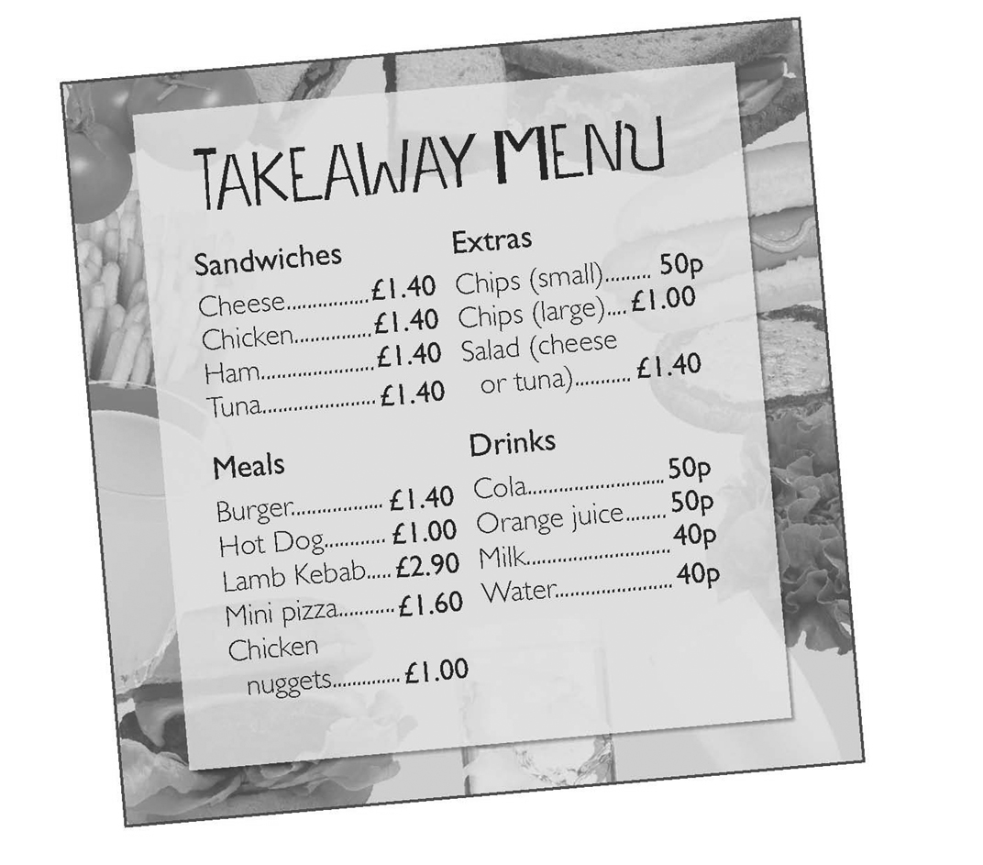
Extras Sandwiches
Chips (small) 2 Cheese
Chips (large) Chicken
Salad – cheese Ham
Salad – tuna Tuna

Extra
Total cost of the order: £ _____
Customer’s telephone number: 01202 _____

Total__________

Audio Script 1
Track 2

Interviewer: Good morning. Please sit down. Now, first of all, could you tell me your name?
Adam: It’s Adam. Adam Waite.
Interviewer: …. Adam … How do you spell Waite?
Adam: W A I T E.
Interviewer: W A I T E. Thank you. And how old are you, Adam?
Adam: I’m fourteen … nearly fifteen .. it’s my birthday next month.
Interviewer: Right. Fourteen. Now, can you tell me a little bit about your family, please, Adam?
Adam: Right. Well we live in London, but my father and I are Irish. My father is originally from Dublin. My grandparents live there and we often visit them for holidays. My mum’s American. She’s from New York. My dad’s 45 and he’s a dentist. My mum’s 41 and she’s an electrician. I’ve got two brothers, Harry and Will, and one sister, Maria. She’s only three.
Interviewer: OK! That’s great. Now what about your hobbies? What things do you like doing?
Adam: I’m into music. I love playing the guitar and I’m really good at it. I don’t mind singing but I’m not a very good singer. We’ve got a piano at home. I never play the piano but my dad often plays it and he’s very good. I love sport. I’m good at football and basketball but I don’t like tennis and swimming very much. Music and sport are my favourite subjects at school.
Interviewer: Are there any subjects you don’t like?
Adam: Well, I don’t mind subjects like science and maths but I hate art. I’m really bad at drawing!
Interviewer: Oh! Now, what about ….
Exercise 2
Track 3
Man: Hello. Happy Snacks. Can I help you?
Woman: Hello. I’d like to order some food, please.
Man: OK. What would you like?
Woman: I’d like two burgers, and one mini pizza, please.
Man: Two burgers, one pizza. Any extras? Chips?
Woman …er.. yes please, some chips.
Man: Large or small?
Woman: Two small chips, please. And ..erm… salads. I’d like one cheese salad and two tuna salads.
Man : One cheese salad, two tuna salads. Anything else?
Woman: Yes , I’d like a sandwich. One chicken sandwich, please.
Man: OK …One chicken sandwich. Any drinks?
Woman: A bottle of cola and two orange juices, please.
Man One bottle of cola and two orange juices. Right.
Woman: . That’s all, thank you.
Man: OK. That’s …er…£12.50.
Woman: £12.50. Right.
Man: And can I have your address and phone number, please?
Woman: Yes, of course, It’s 3 Main Street, and the phone number is 01202 397 564.
Man: 3 Main Street. 01202 397 564.

Test 5 Semester test on Writing
Date___________________ Mark____________
1 Complete Emma’s e-mail to her new pen friend. Write one word in each gap.
To... Jane
From... Emma
Subject: Hi
Hi! Thanks for your e-mail.
I live ¹ _____ Dublin. It’s a great city. My dad is ² _____ teacher and my mum is a nurse. I’ve got two brothers ³ _____ a sister. We live in ⁴ _____ old house ⁵ _____ a big garden.
My hobbies are sport and photography. I’m very good ⁶ _____ swimming. I love cycling, ⁷ _____ When I go cycling in the countryside, I always have my camera with me. I like taking photos ⁸ _____ animals and birds.
On Saturdays, I usually meet my friends and we go shopping in ⁹ _____ city.
On Sundays, my aunt and uncle usually visit us. My uncle is ¹⁰ _____ computers. He often buys us a new computer game. I love playing computer games.
Write soon.
Emma
(½ point for each correct answer)
2 Write a reply to Emma. Thank her for her e-mail and answer these questions about your life.
0 Thank Emma for her e-mail.
1 Where do you live?
2 Have you got any brothers and sisters?
3 What are your hobbies?
4 What do you do on Saturdays?
5 What do you do on Sundays?
To... Emma
From... You
Subject: Hi
Hi Emma! Thanks for your e-mail____________________________
__________________________________________________________________
___________________________________________________________________
___________________________________________________________________
___________________________________________________________________
_______________________________________________________________________________________________________________________________________________________________________________________________________________________________________________________________________________________________________________________________________________
Write soon.

Total__________

Test 6 Semester test on Reading
Date_______________________________________________ Mark_______
1 Read the text. Complete the gaps with these words.
a / and / but / from / in / into / on / on / the / the / too

‘Our neighbours’ by Jim Robinson (aged 14)
Our neighbours are ⁰_the__Smiths. Mr and Mrs Smith have got three sons, Sam, Mark and Andy. My parents and I get ¹ _____ well with the Smiths because they’re very friendly. They’re funny,
² _____ .We always have a good laugh together. The Smiths have got a dog and two cats. Andy takes ³ _____ dog for a walk every day when he gets home ⁴ _____ school.
Mark and Andy go to my school. Mark is seventeen and Andy is fourteen. Andy and I are ⁵ _____ the same class. He’s my best friend. Our favourite subjects are English, music and art. I like history ⁶_____ Andy can’t stand history. He’s really good at science ⁷ _____ he sometimes helps me with my science homework. He’s very patient. We’re both ⁸ _____ computers and we love playing computer games.
Sam is twenty-three and he’s ⁹ _____ teacher. He teaches sport but he doesn’t teach at our school. Sam is really good at swimming and basketball. He often wins swimming competitions. He sometimes goes swimming with Andy and me ¹⁰ _____ Saturdays.

2 Read the text again. Mark the sentences (T) true, (F) false or (DK) don’t know.
Example:
0 Jim Robinson’s neighbours are the Smiths. T

1 Jim and his parents like the Smiths.
2 Jim doesn’t like Andy Smith.
3 Andy doesn’t mind history.
4 Sam is a sports teacher.
5 Sam teaches at a school in London.

Total _______

Test 7 Module 4 Date________________________________________ Mark _______
Vocabulary
1. Sort the letters in brackets to make adjectives.
We saw a strange animal in the jungle. It was very large (A R L E G). It was about three metres 1 _______________ (A T L L) with 2 _______________ (U E H G ) hands and feet. It had a black 3 _______________ (H Y I R A) face and very 4 _______________ (K R D A) eyes. It was really 5 _______________ (O R L E H B I R). We thought it was a very 6 _______________ (U S A N E R G D O) creature so we ran away.
2. Read the sentences. Circle the correct adjectives.
It rained all day and we got very dry / wet.
1 It gets very cold / hot in Spain in the summer.
2 They walked for three days and got very angry / tired.
3 Do you get nervous / tired when you’ve got an exam?
4 What time does it get dark / light in the evenings?
5 My mum is very patient. She never gets angry / scared.
6 He’s getting fat / angry because he eats a lot of chocolate and sweets.

Grammar
3. Complete the sentences with one, ones, another or another one.
Our dog is the little brown one.
1 These computer games are my new __________.
2 I’m very hungry. Can I have __________ sandwich, please?
3 This mystery story was fantastic. I’d like to read __________ by the same author.
4 Is John’s jacket the black and red __________ ?
5 We’ve got some expensive bags but we haven’t got any cheap __________.
6 He watched a horror film last night and he’s watching ________________ scary film now.
4. Complete the sentences with the correct form of the verbs in the Past Simple and Past Continuous.
Last Monday morning, my mum 1 __________ (listen) to the radio and I 2 _____________ (have) breakfast when the postman 3 ______________ (ring) the bell. He was very wet because it 4 ______________ (rain). He 5 __________ (have) about fifteen cards and a big box for my mum. It was her birthday! We 6________________ (make) present for her.
Communication
5. Read the information in the box. Then complete the sentences with after, before or during.
What did Jane and Sue do yesterday?
9.00 am | had breakfast
10.00 am | went to the swimming pool
11.30 am – 12.30 pm | walked in the park
(11.50 am – met Peter)
12.30 pm – 1.30 pm | had lunch
2 pm – 3 pm  3 pm – 4 pm | listened to CDs  went shopping
5 pm – 5.30 pm | Sue had a guitar lesson
6 pm – 6.30 pm | had dinner
7 pm – 9 pm | finished a school project

After breakfast, Jane and Sue went to the swimming pool. 1 __________ their swim, they went for a walk in the park. 2 __________ their walk, they met Peter. 3 __________ lunch, they listened to CDs. 4 ___________ she went shopping. 5 __________ dinner, Sue had a guitar lesson. 6 __________ dinner, they finished a school project.

6. Complete the story with these words
after / like this / so / suddenly / then / when
A: Why is there a big hole in your garden? It wasn’t there yesterday.
B: Well, it’s1 ________ ___. Last night, we had a very strange experience. It was about 10.30. Mum and dad were watching the news on TV and I was asleep in bed. 2 _______________, there was a loud noise in the garden. I woke up. 3 _______________ I looked out of my bedroom window, I saw a huge thing in our garden. It was a spaceship. It made a big hole in the garden.
A: What did you do?
B: My dad and I went into the garden. 4 _______________ a few minutes, the door of the spaceship opened and three aliens walked out. They were very hungry 5 _______________ mum gave them some sandwiches. They had their sandwiches, thanked us and 6 _______________ they got into their spaceship and left! Honestly!
Vocabulary________
Grammar_________
Communication ________
Total________

Test 8 Module 5 Date______________________________________ Mark _______
Vocabulary
1 Read the sentences. Circle the correct words.
The film wasn’t very interested / interesting.
1 I had two exams today so now I’m tired / tiring.
2 We were amazed / amazing when we saw his new hairstyle.
3 It was a really frightened / frightening story about the end of the world.
4 I didn’t finish the book. It was bored / boring.
5 Are you interested / interesting in films?
6 This computer game is too easy. I’m bored / boring.
2. Look at the pictures. Write the names of the clothes.
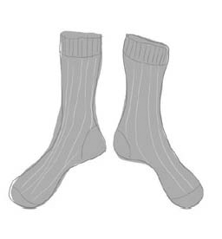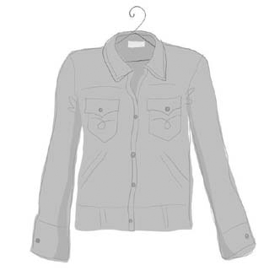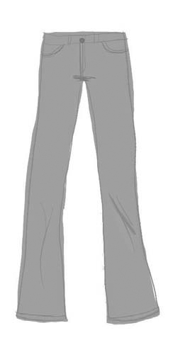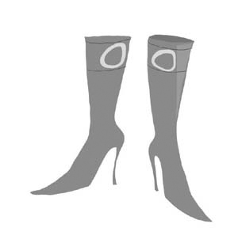
1 ____________________ 2 ____________________ ________jeans__ 6________________
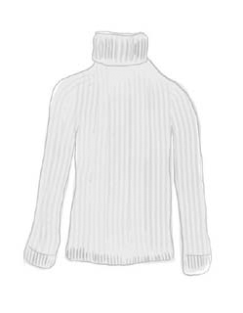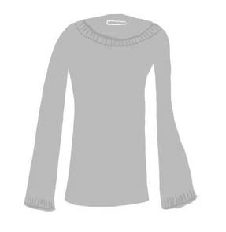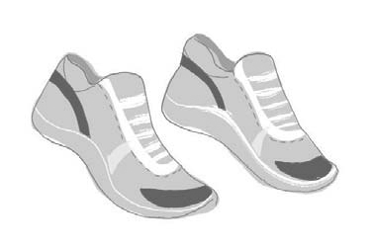
3 ____________________ 4 ____________________ 5 ____________________
Grammar
3. Look at the information in the table. Complete the sentences with the comparative or superlative form of the adjectives in brackets.
The white boots are _the biggest. (big)
1 The brown boots are ____________________ (big) than the black boots.
2 The brown boots are ____________________ (cheap) than the red boots.
3 The black boots are ____________________. (expensive)
4 The black boots are ____________________. (small)
5 The black boots are ____________________ (expensive) than the red boots.
6 The red boots are _______________. (expensive)

 | BOOTS
Colour | Size | Cost (euros)
black | 36 | 60
brown | 38 | 85
Red  White | 40  38 | 100  99

4 Complete the questions with these expressions. There is one extra item.
How tall? / How long? / How many?
______How old ______ is the baby? 6 months.
1 ____________________ brothers have you got? 2.
2 ____________________ is this lesson? 45 minutes.
3 ____________________ is he? 1.5 metres.
5 Complete the sentences. Use too or enough and the adjective in brackets.
Tim is twelve years old. He isn’t _____old enough ____ to drive a car. (old)
1 Sue wants to be a fashion model but she isn’t ____________________. (slim)
2 John’s mum thinks his hair is ____________________. (long)
3 Liz is only three years old. She’s ____________________ to go to school. (young)
Communication
6. Match the questions (1–5) with the answers (a–e).
Is Maria slim? __(f)_ (a) They look great.
1 How much is this? _____ (b) No, they’re not big enough.
2 Are your shoes comfortable? _____ (c) She’s got dark curly hair and blue eyes.
3 What do you think these jeans? _____ (d) Yes. She’s got a pony tail.
4 Has she got long hair? _____ (e) 50 euros.
5 What does Ann’s sister look like? _____ (f) No, she’s quite plump.
6 Does this blue T-shirt look OK? _____ (g)Yes, it really suits you.
7. Write the sentences in the correct order to make a ‘shopping’ conversation.
A: Can I help you?
1 A: What colour?
2 A: Here are some nice ones. What about this one?
3 B: That’s a bit too dark. But I like this one. How much is it?
4 B: Yes. I’m looking for a T-shirt in a large size.
5 B: Dark green, please.
6 A: 15 euros
A: Can I help you?
B: ______________________________________
A: ______________________________________
B: ______________________________________
A: ______________________________________
B: ______________________________________
A: _______._______________________________

Vocabulary________
Grammar_________
Communication ________
Total________

Test 9 Module 6 Date____________________________________ Mark _______
Vocabulary
1 Match the words to make expressions.
swimming (e) (a) boat
1 mineral _____ (b) ticket
2 amusement _____ (c) water
3 fishing _____ (d) boots
4 single _____ (e) pool
5 walking _____ (f) park
2. Complete the sentences with the correct form of the words in brackets.
A: Did you have a good holiday?
B: Yes, thanks, we had a ____lovely____ (love) time. We had a very 1 ______________ (act) holiday because we went skiing in 2 ______________ (north) Italy. It was very 3 ______________ (beauty) in the mountains and it was usually 4 ______________ (sun). The views were 5 ______________ (wonder). The skiing was 6 ______________ (adventure) but it wasn’t 7 ______________ (danger).
Grammar
3. Read the sentences. Circle the correct words
We heard anything / something in the garden.
1 She’s very popular. Everybody / Somebody likes her.
2 I’m bored. I haven’t got anything / nothing to do.
3 I can’t find my English book anywhere / everywhere.
4 Are you all right? Is everything / anything OK?
5 I didn’t know anybody / somebody at the party.
4. Write questions with How many? and How much?
____How many___ students are there in your school?
1 _______________ pencils did you buy?
2 _______________ snow was there on the mountain last year?
3 _______________ children went to the party?
5. Read the sentences. Circle the correct words
Are there any / no good restaurants here?
1 Sue’s got a lot of / no cousins – about twenty, I think.
2 I’d like some / any information about Scotland, please.
3 There’s no / some chocolate left. I ate it all last night.
Communication
6 Complete the conversation at the Tourist Information Office with these words. There is one extra word.
Can / go / help / how / much / single / take
A: Good afternoon. How can I 1_______ you?
B: 2 ______ you tell us 3______ to get to the Exhibition Centre, please?
A: You can 4 ______ the train or go by bus. The train is quicker but it’s more expensive. The buses go every twenty minutes.
B: How 5______ are the bus tickets?
A: Six euros for a 6______ and ten euros for a return.
B: Thanks very much. We’ll have two returns, please.
7. Punctuate the e-mail from Chris. Use these punctuation marks:
full stop (.) / comma (,) / question mark (?) / exclamation mark (!) / apostrophe (’) / dash (–)

Hi Anna __,_
How are you 1 ( )
I 2 ( ) m having a great time in London 3 ( )
We went shopping yesterday 4 ( ) I spent all my money 5 ( )
Would you like to go to London 6(_)
Chris

Vocabulary________
Grammar_________
Communication ________
Total________
Test 10 Semester test on Listening
Date_____________ Mark__________
Tracks 6-7
- Listen to a radio programme about people’s holidays last year. What did each person do? Write the activities (A-I) next to the people (1-8).
Ann D
1 Ann’s brother, John 5 Maria’s cousin, Anita
2 Ann’s dad 6 Maria’s uncle
3 Pete’s mum 7 Mike
4 Pete’s girlfriend, Sue 8 Mike’s mum
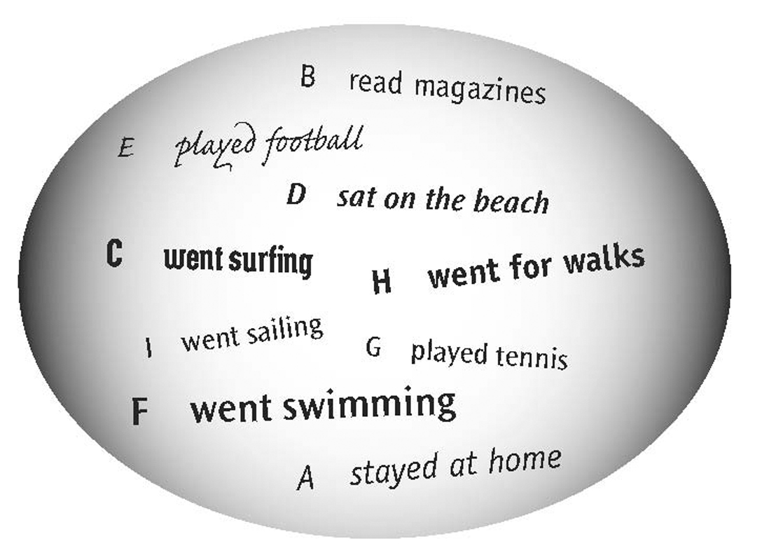
2. Anna and Tom are shopping. Listen to the conversation in a clothes shop. Read the questions and tick the correct answer (A, B or C).
What does Anna want to buy?
A a T-shirt B a jumper C a top ✓
1 How much is it?
A £8 B £9 C £10
2 What size are Anna’s jeans?
A small B medium C large
3 How much are they?
A £11 B £14 C £15
4 What colour is Tom’s T-shirt?
A red B dark blue C light blue
Track 6

1
Presenter: Welcome to Radio Sunshine. Today we’re talking about holidays. Let’s listen to Ann, talking about her holiday in Spain.
Ann: Hi. I’m Ann. Last summer I had a great holiday. I went to Spain with my mum, my brother John and my best friend Linda. The weather was fantastic. I went to the beach every day with Linda and John. They like swimming in the sea but I don’t. I sat on the beach all the time. John and Linda went swimming every day. Mum doesn’t like the beach. She likes towns and cities. She went sightseeing and saw a lot of famous places. My dad didn’t come to Spain. He stayed at home because he was working during the summer.
2
Presenter: Pete went to France. Listen to his holiday story.
Pete: Hello. My name’s Pete. Last year I had a holiday in France. I went with my parents and my girl friend Sue. We stayed at a campsite in the countryside. My dad’s hobby is fishing and he went fishing in the river near our campsite. He didn’t catch a lot of fish but he had a good time. Mum loves walking in the countryside and she went for a long walk every morning. I took my bike to France and I went cycling every day. I’m really into cycling. I thought my girl friend, Sue, liked cycling too, but she doesn’t. And she doesn’t like camping so she wasn’t very happy. She stayed at the campsite every day and read a lot of magazines and books. I don’t think she had a very good holiday because she stopped going out with me when we got back home. I’ve got a new girlfriend now and she likes cycling.
3
Presenter: Now let’s listen to Maria. She went to the seaside.
Maria: Hello. My name’s Maria. Last July I stayed with my aunt and uncle and my cousin Anita. They live near the sea and they’re into water sports. Anita and I love surfing. We went surfing every day and we had a fantastic time. Anita is better than me at surfing and she helped me a lot. My uncle has got a boat and he went sailing every morning. My aunt tried snorkelling for the first time. She really liked it and she went snorkelling a lot on holiday.
4
Presenter: And last we have Mike. Mike went on an activity holiday.
Mike: Hi, I’m Mike. I went on an activity holiday for a week with my mum, my dad and my sister Jane. We had a lot of fun. I played football every day and our team won a competition. My dad went horse-riding. His horse was huge but it was very friendly. Mum’s favourite sport is tennis and she played tennis a lot on holiday. My sister Jane wanted to learn to play volleyball. She played every day and got really good at it. She’s in the volleyball team at school now.
Exercise 2
Track 7

Assistant: Can I help you?
Anna: Yes, I’m looking for a top.
Assistant: What size are you?
Anna: Medium. I’d like a bright colour – red or green perhaps.
Tom: These yellow ones are nice, Anna.
Anna, Yes, they are, but yellow doesn’t suit me. Oh, this red one is lovely! Yes, I’d like this one, please. How much is it?
Assistant: The red top’s £8.
Anna: Right. I’d like some jeans, too.
Assistant: The jeans are over there. Do you want a medium size?
Anna Yes, that’s right. Oh, you’ve got a lot of fantastic colours – red, blue and my favourite colour – green! Yes, these are great! I’d like the green jeans, please. Are they £15?
Assistant: No, these are cheaper. They’re £11.
Anna: Oh, good.
Assistant: That’s a total of er … £19.
Anna: Here you are.
Assistant: Thank you.
Anna: Do you want to look at the T-shirts and jackets, Tom?
Tom: Mm ..yes. Have you got any large T-shirts?
Assistant: Yes, the large sizes are here. We’ve got red and blue.
Tom: Er .. not red for me. The blue ones look good … er … I think the light blue is a bit too light but I like the darker ones. Yes, I’d like this dark blue one, please. How much is it?
Assistant: It was £30 but it’s only £15 now.
Tom: £15. That’s great. And have you got any jackets in a large size?
Assistant: Yes, these are the large sizes. We’ve got green, black and brown.
Tom: I’ve got a black one .. er … I don’t mind brown but …
Anna: What about this green one?
Tom: Yes, that’s really nice. How much is it?
Assistant: It’s £20.
Tom: Yes, I’d like the green one, please.
Assistant: Fine. So that’s … er … £35 for the T-shirt and the jacket.
Tom: Right. Here you are.
Assistant: Thank you.

Test 11 Semester test on Writing
Date___________________ Mark____________
- Complete the postcard. Write one word in each space.

_Hi_ Carol, Thursday  I’m 1 __________ London for four days 2 __________ my parents. The weather is quite good. It rained yesterday but it’s sunny today. We’re staying in 3 __________ small hotel in the city centre. We’re having 4 __________ great time and doing a 5 __________ of sightseeing. 6 __________ Monday, we went on a boat trip on the River Thames and we had lunch on the boat. 7 __________ the evening, we went 8 __________ the cinema. After the film, we went to 9 __________ Indian restaurant and had a fantastic curry. This morning we went shopping and I 10 __________ some great T-shirts. I got a black and white one for you.  I hope you're having a good half-term, too. See you at the weekend.  Sally | 
Carol Potter
6 Bridge Street
Rumpton
Middx

5 points (1/2 point for each correct answer)

2. Write Carol’s postcard to Sally. Use the information in the table. 7 points
CAROL’S HALF TERM HOLIDAY
Where | grandparents’ cottage near the sea
Weather | hot and sunny
Monday | swim / snorkel dinner at Italian restaurant
Tuesday | cycle to old castle / picnic cinema
Wednesday | Shopping

_Hi_ Sally! Thursday  I hope you’re having a fantastic time in London. I’m staying with my grandparents and I’m having a great holiday. They live ________________________________  _______________________________________________  _______________________________________________  _______________________________________________  _______________________________________________  _______________________________________________  _______________________________________________  _______________________________________________  _______________________________________________  _______________________________________________  _______________________________________________ |  | Sally Jackson  26A Well Road  Bligh  Kent

Total_______

Test 12 Semester test on Reading
Date_________________________ Mark______________
- Read the text. Complete the gaps with these words.
a / during / everywhere / on / some / to / when / with
Luke stayed _with_ his uncle for a holiday last winter. His uncle lives on 1 __________ small farm in the north of England.
It was the last day of Luke’s holiday. His uncle was very busy on the farm. Luke decided 2 __________ take one of his uncle’s dogs, Rex, for a long walk. He got up early and put 3 __________ his warm trousers and his walking boots. Rex was excited and was running round the kitchen. Luke made 4 __________ sandwiches and put them in his bag.
When Luke and the dog left the house, it wasn’t very cold and there wasn’t much snow. They walked all morning in the countryside. Rex was enjoying the snow and running 5 __________. 6 __________ the afternoon, it started to snow again but Luke wasn’t worried.
Then it happened. Luke was walking across a field 7 __________ he fell and hurt his leg. The dog ran back to him. Luke thought he had his mobile phone in his bag. He opened the bag. There was no mobile in it! It was getting dark and he was getting frightened. He looked across the fields. There was nobody there. Suddenly, the dog turned and ran off. Where was he going?
It got colder and Luke was getting more frightened. Then, after about half an hour, he heard noises. Somebody was coming. Two men arrived with Rex. One of them told Luke: ‘Your dog ran to our village.
We knew something was wrong and so we followed him and he brought us here. You’re very lucky!’ The ambulance soon arrived and took Luke to hospital.
- Read the text again. Mark the sentences (T) true, (F) false or (DK) don’t know.
Luke stayed with his uncle for two weeks. DK
1 Luke’s uncle has got three dogs. _____
2 There wasn’t a lot of snow when Luke left his uncle’s house. _____
3 Luke got very scared when it started to snow. _____
4 Rex stayed with Luke all the time. _____
5 Luke broke his leg. _____

