

Olga Shevchenko

Ukraine

TEA Program, Fall 2009

George Mason University, Virginia

- Foreword
- Curriculum Vitae
- Reflections
- GMU Seminars
- Lesson Plans
- Lesson Strategies
- Shared Strategies and Lesson Plans
- Internship
- Multicultural Day
- Resources
- My Home Assignments
- Afterword

The brighter you are the more you have to learn
Don Herold

Once again I am a student. This feeling is not new for me but still it is very exciting and unforgettable. I am really glad that I am a TEA fellow and my host university is George Mason University.

I have learnt a lot of new things not only as a teacher but as a personality as well. When you communicate with different people you realize how bright the world is, how rich the world is, how many new and interesting things are around.

Here in my portfolio I gathered the material I had been working on during my studies. But of course that is not all. I am taking much more in my head. There are a lot of things I have to analyze, to reflect on, to discuss with my colleagues.

Olga Shevchenko
100 Franko Street, Flat 12
Zhmerynka, Ukraine
Professional experience
School-lyceum – Zhmerynka, Ukraine
Teacher of English (08/2001-present)
- Teach English to grades 2-12
- Head of Methodological Commission (2006-present)
- Secretary of Pedagogical Council (2006-present)
- Member of School Methodical Council (2007-present)
- Winner of the competition “The Teacher of the Year-2008” (December, 2008)
- Winner of the competition “The Young Person of the Year- 2009” (June, 2009)
- Winner of the competition “The Person of the Year- 2009” (September, 2009)

Kyiv International University
Regional Preparatory Course
Teacher of English (10/2001-05/2007)
European University (Vinnytsia Branch)
Teacher of English (09/2003-05/2005)

Education
Vinnytsia State Pedagogical University-Vinnytsia, Ukraine
Diploma (09/1996-06/2001)
Department of Foreign Languages
Winner of the republican Olympiad in Esthetics (Third Prize) (04/2000)

Vinnytsia Pedagogical College- Vinnytsia, Ukraine
Diploma (09/1993-06/1997)
Department of Elementary Education
Winner of the oblast Olympiad in Ukrainian History (third Prize) (05/1995)

Professional Development
Coordinator of EFL Teachers Conference (March, 2006)
A conference on how to teach discussions in secondary school for 30 teachers of Zhmerynka

Advanced Training Course – Vinnytsia, Ukraine
Institute of Postgraduate Education of Teachers (May – June, 2005)

Computer Skills
Microsoft Word, Power Point

Languages
Ukrainian (fluent), Russian (fluent), English (excellent)

Reflection about my fieldwork assignment
Since I am in a constant progress of looking for new teaching and learning strategies, the chance to observe firsthand experience of the US ESOL teachers is a great opportunity for me.
After my first day at a US school I have worked out several key points which I am going to research:
1. Teaching strategies, methods and techniques (the ways the teachers present, explain, organize the teaching material and activities).
2. Learning strategies (the ways the students perceive, understand, remember and put in practice the material in class).
3. Classroom management (how the teachers manage the students’ behavior, the timing in class, the ways of keeping the students’ attention).
4. Assessment techniques (how the teachers evaluate the students’ knowledge, understanding and practical skills).
5. Use of technology (the ways the technology is used at different stages: at the stage of learning and the stage of assessment).
Though there are many visible differences in the US and Ukrainian schools (these differences are connected with the traditions of the development of school systems in both countries), it seems to me that the most important differences are motivation and background knowledge.
On the one hand, for the US ESOL teachers the main challenge is to involve the students into active participation during the class. There is no need to make the students sure they need English for their everyday life. For the Ukrainian teachers the task is double difficult. We must break through the wall and make our students believe that they are learning English not for the sake of it, but because it will give them more opportunities. On the other hand, Ukrainian students have deeper background knowledge and there is no need for the teacher to go into detail about the topics being covered in class. I think these are the main cultural differences.
The experience I will get in the US is valuable for me because I will develop new ideas on my individual teaching style combined with the main guidelines which I am given at the sessions and at school. I will start to compile my teacher’s portfolio for the improvement of my reflective practice and sharing my experience and ideas with my colleagues.

What kind of incident causes you to reflect on your teaching? How does that reflection inform your teaching? Do you share your reflections with colleagues? Supervisors?
I reflect on my teaching all the time because I am always unsatisfied with what I am doing: I think I can do better. I am looking for new ways of improving my teaching methods and techniques, but sometimes it turns out that I cannot implement what I have thought of just because some of my students have not done their homework and the activities I have prepared are based on it. I find it distressing because I have to change my plan completely. I am really sorry for the time being wasted. I always feel lack of time because there are a lot of things I would like to do. And when my efforts and time are wasted I feel really angry.
I am aware of the fact that the achieving of success at the lesson depends both on the teacher and the students. If one party fails, the whole system does not work properly.

What is the purpose or goal of a portfolio in your country?
We do not have portfolios as they are in Ukraine, but every teacher in the country should have a binder with the main documents on the standards, methodical recommendations, etc. As far as reflective practice is concerned, we do not do it in writing. After any demonstration lesson a teacher usually does a self-analysis but orally. We do this for knowing and understanding what our goals are and for improving our teaching skills.

What factors does the teacher consider in planning?
- National standards.
- Objectives of the lesson.
- Individual peculiarities of the class as a whole.
- Differentiated instruction.
- The principles of the brain-compatible teaching and learning (multiple intelligences, learning styles, 4MAT System, etc.).
- Timing.
- Variety of activities.
- Assessment.
- Reflection from the previous class.
- Integrated curriculum.

How does a teacher use objectives in planning? Are there differences between your country and the fieldwork schools here?
The teacher sets objectives according to the standards and requirements and chooses the strategies, activities, visual aids that will help to fulfill these objectives.
In Ukraine we have main guidelines set by the European Common Framework, the Program on teaching English and the requirements and methodological recommendations from the Ministry of Education. The teacher has the right to choose what he/she thinks will help to achieve the goal.

How can group work aid your teaching?
Group work is very effective for facilitating students’ independent work and giving them an opportunity for interaction. Group work develops social skills alongside with learning skills.
The teacher’s task is to organize group work as early as possible so that the students can be motivated to speaking English to each other. The students should also know that though they work in a group, the teacher has effective tools for evaluating their work.

- Seminar on Professional Development and Change: Reflective Practice and Portfolio Development
We realized that reflective practice was critical to meaningful growth and change. We were provided with a platform for integrating our individual experiences, professional goals, professional development experiences while in the U.S., encompassing both fieldwork and coursework, and work on developing our individual action plan for implementation upon return to our home countries. We examined our professional identity and change agency, reflected on educational and administrative structures and systems within which we practiced our teaching profession in our home countries. We undertook a self-assessment in order to hone our individual goals for the duration of the program and develop individual goals for each of our seminars and independent research sessions. As a result we are prepared to present and implement portfolios for disseminating innovation upon return to our home schools.
- Educational Leadership Program
We examined functions of leadership and management and foundations of the American school system. We explored organizational theories and models of leadership and management and personal and organizational change. We bridged theory to practical applications in educational settings. We were provided with an opportunity to explore meanings of leadership in schools, leaders’ role in school change and restructuring; and ways school leaders make sense of school organization.

- ESL/EFL Research and Assessment
The seminar course was based according to three important educational pillars: research, methods, and assessment. We identified questions on prime topics around brain-compatible learning and teaching practices. We learned to implement differentiated methods and lessons to English language learners (ELLs) while developing students’ language ability. The third important matter was assessing students understanding and if the objectives were met in the classroom by integrating “authentic assessment”.

- Special Professional Development Topics:
- Professional Development Portfolios and Reflective Practice (Dr. Rebecca Fox)
- Ability and International Education (Dr. Beverly Sheklee)
- Multiple Intelligences (Dr. Marjorie Haley)
- The Role of Community in Education (Svetlana Filiatreau)
- International Cases for Instructional Improvement (Dr. Chris Johnston)
- Education Leadership in 21st Century Schools (Dr. Alan Sturrock)
- World Englishes and Teaching Writing to the ESL Students (Dr. Paul Matsuda)

- WATESOL Fall Convention 2009 (Chevy Chase, Maryland)
“Improving Outcomes Through Quality Instruction”
- Integrating Pronunciation into Grammar and Vocabulary Instruction (Sue Miller)
- Engaging Learners through Collaborative Writing Projects (Donette Artenie, Sigrun Biesenbach-Lucas, Georgetown University)
- Practical Techniques for Developing Reading Fluency (Carol Romett, Georgetown University)
- Practice Makes Perfect: Giving Presentations with PPT Slides (Sigrun Biesenbach, Georgetown University)
- Ready, Aim: Read for Speed and Enjoy (Dale Ringer, Fairfax County Public Schools, Adult ESOL)

Nothing great was ever achieved without enthusiasm
Ralph Waldo Emerson



Sample Lesson Plan 1. Implementing the theory of multiple intelligences (MI).
Content: My Working Day
Objectives:
- Improving students’ speaking and writing skills.
- Involving the students into the active participation during the lesson.
- Teaching them to be well-organized and to plan their time.
Procedure of the lesson:
Activity 1.
Warm up. Mind-mapping “My Working Day” (Spatial Intelligence).
Activity 2.
Listen to the song “The copycat”, then
- fill in the missing phrases in your handouts;
- read the song;
- sing along and act it out;
- make up your own verse, pay attention to the third person singular of the verbs.
(Linguistic, Musical, Bodily- Kinesthetic Intelligences)
Activity 3.
Journal Writing. Use a graphic organizer and write what you usually do in the morning (in the afternoon, in the evening).
(Logical- Mathematical, Intrapersonal Intelligences)
Activity 4.
Pair work. Interview each other and report on the information you have.
(Interpersonal Intelligence)
Activity 5.
Whole class discussion. Do you have time to take care of your pets and plants?
(Naturalistic Intelligence)
- Home Assignment. Prepare a Power Point Presentation “My Ideal Day”(Intrapersonal Intelligence) 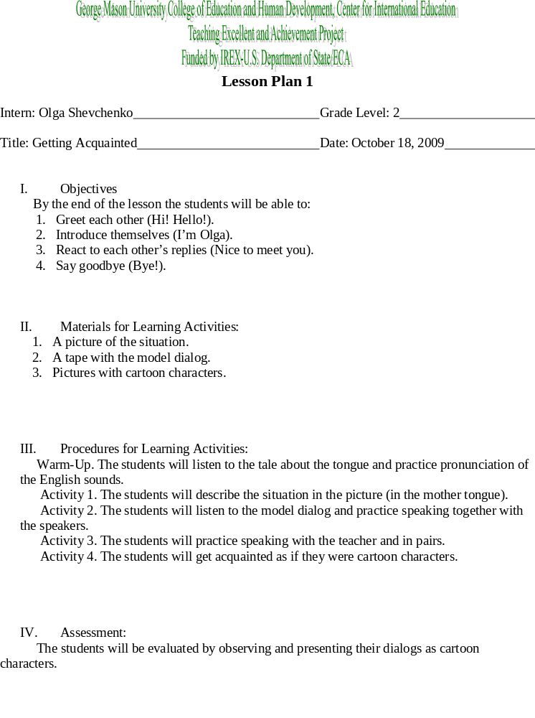V. Differentiation
As the students are at the very beginning of learning English, it will take some time to see how fast and how easily they can acquire skills.

- Reflection
All the small kids are eager to learn a new language. The task of the teacher is to make the process interesting, stimulating and challenging to some extent.
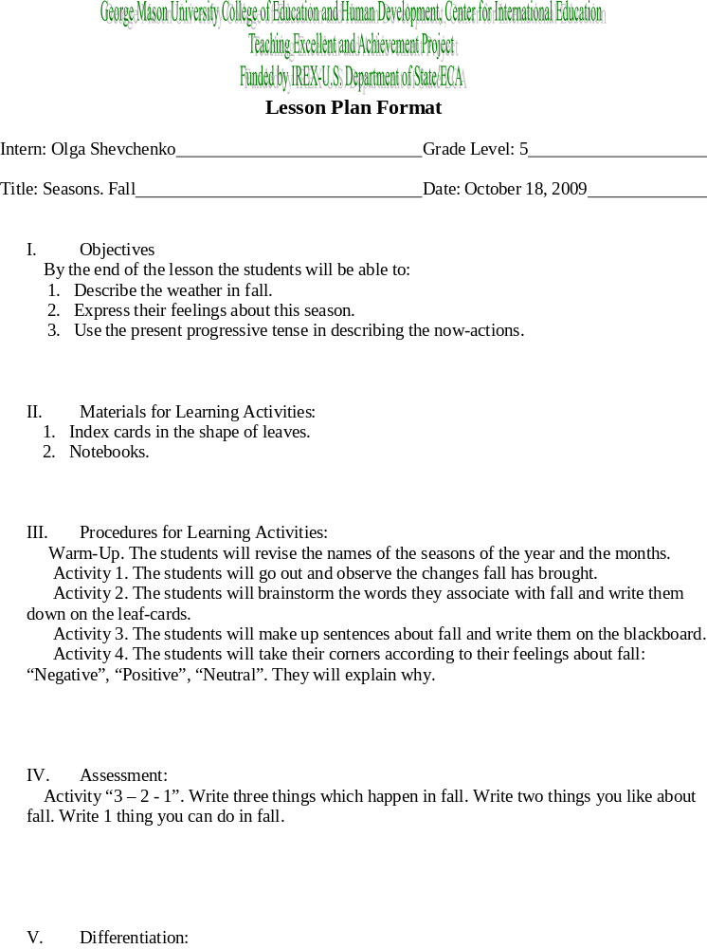 Starting Up. These students will do the observation and take their corner.
Beginning. These students will participate in the warm-up, Activity 1 and will take their corner.
Developing. These students will participate in the warm-up, Activity 1, 2 and take their corner.
Expanding. These students will make up sentences.
Bridging. These students will make up sentences and explain their group’s feelings about fall.

- Reflection:
This lesson is good for developing and activating Naturalistic and Bodily- Kinesthetic Intelligences. It gives the opportunity to integrate English and Nature Study.

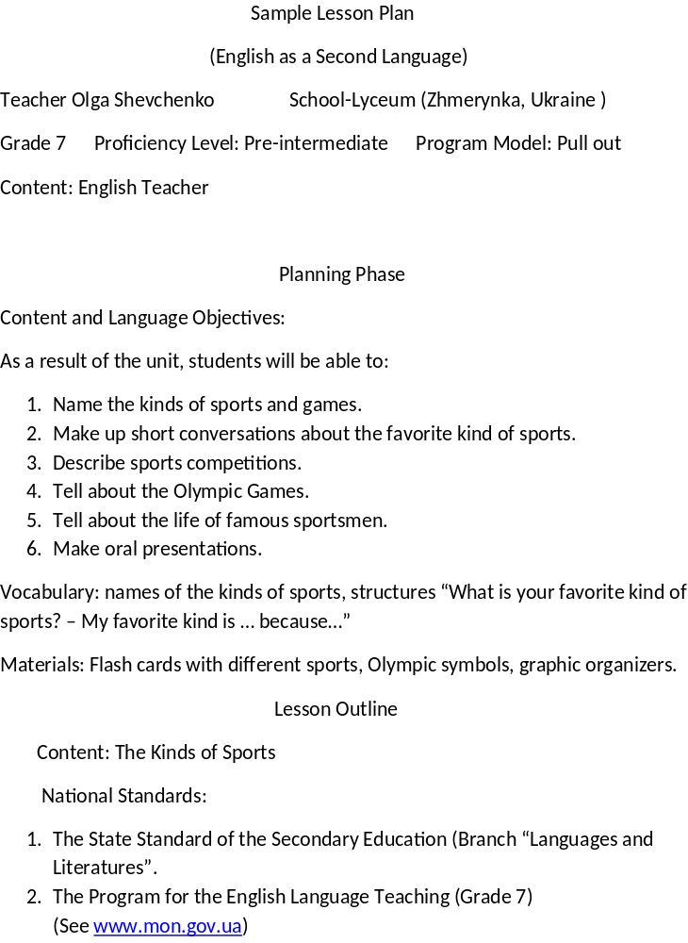
- European Common Framework (Level A2)
(See www.coe.int/t/dg4/linguistic/source/Framework_EN.pdf)

Teaching Phase Sequence
Lesson 1
Warm –Up Activity:
Read a short rhyme on sports. Name the kinds of sports mentioned in it.(Entire class work)
Transition:
Students guess the content of the lesson and write the new vocabulary in the notebooks. The teacher pays attention to the term “international words”.(Individual work)
Activities
Activity 1: Show the pictures with different kinds of sports to the students. Work on the meaning and pronunciation of the words. Write down the new vocabulary.(Entire class and individual work)
Activity 2: Miming game. A student mimes a kind of sports, the other students guess what it is.(Entire class work)
Activity3: Group the kinds of sports according to the categories “Individual Sports”, “Team Games”, “Indoor Sports”, “Outdoor Sports”. (Individual work)
Activity 4: Role-play “An Interview”. One student (the strongest one) is a reporter. He/she asks the group members questions about their favorite kinds of sports and writes the information down. (Small group work) Then the reporters gather together and classify the data and report on it (Activity 4a). (Small group work) The other students do another activity “Jumbled Words” (Activity 4b).(Individual work)
Differentiated Instruction
Starting Up: Students can participate in Warm-up and Activities 1, 2, 3.
Beginning: Students can participate in Warm-up and Activities 1, 2, 3.
Developing: Students can participate in Warm-up and Activities 1, 2, 3, 4, 4b.
Expanding: Students can participate in Activity 4, 4a.
Bridging: Students can participate in Activity 4, 4a.
Assessment:
The evaluation will be done by observing the students during the lesson and taking notes.
Closure:
- Write 3 kinds of sports you would like to go in for.
- Write the reason of choosing these very sports.
Homework:
- The students will learn the new vocabulary.
- The students will find information on the history of the Olympic Games.

Lesson 2
Content: The Olympic Games
Warm-Up Activity.
The students will match the kind of sports and the name of the person who goes in for this kind of sports.
e.g. tennis – a tennis- player (Individual work)
What are the ways of forming such nouns? (Entire class work)
Transition
The students will discuss the questions:
Where can athletes show how skillful they are? What kind of competitions is the dream of every athlete? (Entire class work)
Activities
Activity 1: Jigsaw reading. The students will read the text “The Olympic Games” and fill in the table. (Small group work)
The Olympic Games
The origin…
The main idea…
The motto…
Kinds of the Olympics…
The symbols…
Kinds of sports…
Activity 2: Q&A. One group (stronger students) will ask questions, the other group (weaker students) will answer them using the table. (Group work)
Differentiated Instruction
Starting Up: These students can participate in the warm-up, Activity 1(fill in the table), Activity 2 (answer the questions).
Beginning: The same activities like Starting Up.
Developing: These students can participate in the transition.
Expanding: These students can participate in Activity 1 (reading and sharing the information), Activity 2(asking questions).

Bridging: The same activities like Expanding.

The teacher will check the filled tables and take into consideration the oral answers.
Closure
Write 3 things that you’ve learnt about the Olympic Games.
Write 2 things that are the most interesting for you.
Write 1 thing about which you want to know more.
Homework
- Use the table and write about the Olympics (Developing, Expanding, Bridging)
- Prepare flashcards with different kinds of sports and Olympic symbols.

Lesson 3
Content: Famous Ukrainian Sportsmen. Serhiy Bubka – a pole – vaulter.
Warm-Up
The students will take flashcards prepared by their classmates and make up sentences. (Entire class work)
Transition
The students will start filling in the KWL – chart about S. Bubka. (Individual work)
Activities
Activity 1: The students will listen to the text about S. Bubka and say if the facts they have written in the first column are true.(Individual work)
Activity 2: The students will listen to the text again and complete a timeline of his life. (Individual work)
Activity 3: Discuss your timelines and report the information. (Small group work)
Differentiated Instruction
Starting Up: The students will participate in the warm-up, the transition and will make the lifeline with the help of their classmates.
Beginning: The same tasks like Starting Up.
Developing: The students can participate in Activity 1.
Expanding: The students can participate in Activities 2, 3.
Bridging: The students can participate in Activity 3.
Assessment
The teacher will evaluate the oral answers and the lifelines of the students.
Closure
The students will fill the third column of the KWL – chart. (Individual work)
Homework
Make a lifeline of any famous sportsmen.

Lesson 4
Content: Getting Ready for the Project Work
Warm up
The students will share their lifelines. (Small group work)
Transition
Brainstorming. The students will draw a mind-map answering the question “What do you think about when you hear the word “Sport”. (Entire class work)

Activities
Activity 1: The students will discuss the outline of the project and draw a mind-map. (Partners and entire class work)
Activity 2: The students will discuss the format, the way of presenting and the standards of evaluation. The students will make a rubric.(Small group and entire class work)
Differentiated Instruction
The students of all proficiency levels will do the same tasks.
Assessment
The teacher will evaluate how active the students were in discussing the projects.
Closure
The students will answer the question “What should you take into account preparing a project work?”
Homework
Prepare the project work

Lesson 5
Content: Project Presentation
Warm-Up
The students will answer the question “How well does my presentation meet the standards?” (Individual work)
Transition
Each student gets 3 experts to evaluate his/her presentation.
Activities
Activity 1
The students present their projects.
Activity 2
The experts evaluate the projects and report to the class. The students must agree or disagree with the evaluation.
Differentiated Instruction
All the students will participate in all the activities. The teacher should form the groups of experts in such a way that the groups consist of the students with different proficiency levels.
Assessment
The students will be evaluated according to the quality of their projects and their work as experts.
Closure
The students will answer the question “How well did my presentation meet the standards?”
Homework
Write the recommendations for a good presentation.

Teachers open the door, but you must enter by yourself.
Chinese Proverb

Education is not preparation for life; education is life itself.
John Dewey

We learn by doing, achieve by pursuing.

By learning you will teach; by teaching you will learn.
Latin proverb

Lessons hard to learn are sweet to know.
Proverb

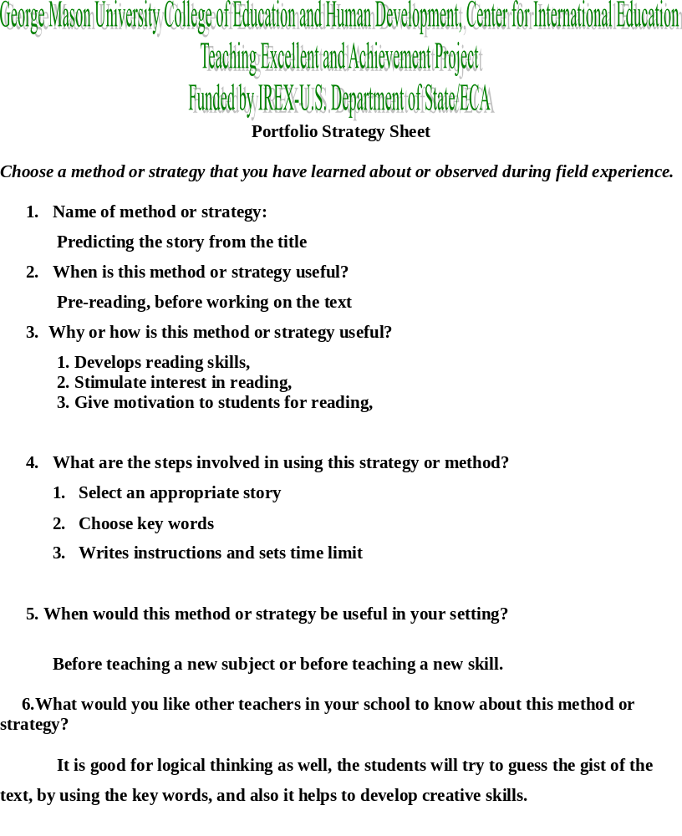
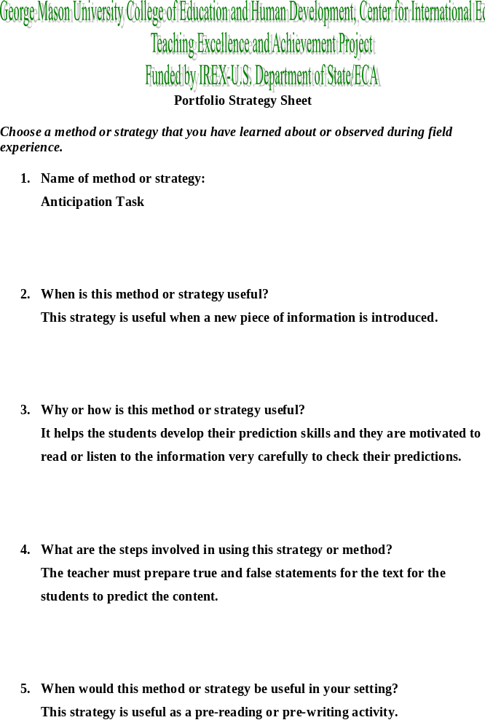
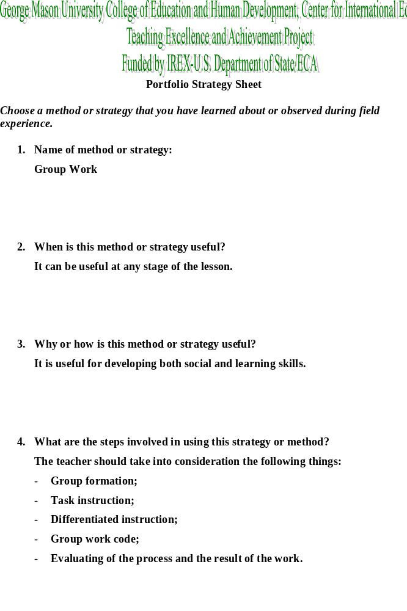
5.When would this method or strategy be useful in your setting?
This strategy is already used by Ukrainian teachers and has proved to be an effective one at the English lesson.

- What would you like other teachers in your school to know about this method or strategy?
I would like them to be more careful in setting the task and assessing both the process and the outcome.

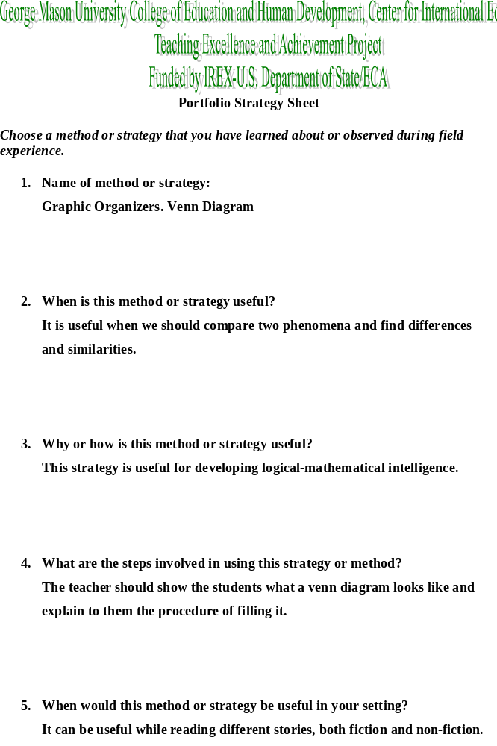
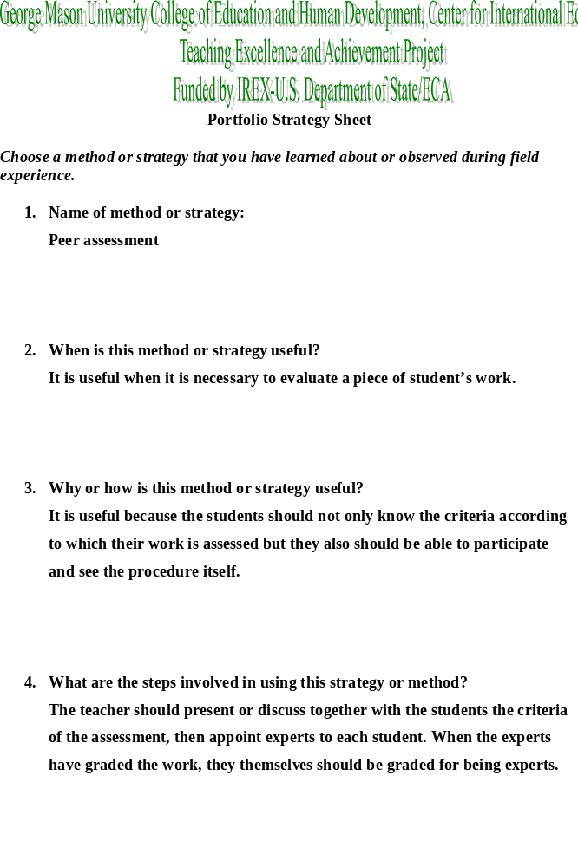

- When would this method or strategy be useful in your setting?
This strategy can be useful in my setting because we always assess our students at the lessons. Why shouldn’t we give a chance to the students themselves.

- What would you like other teachers in your school to know about this method or strategy?
This strategy helps the students improve their own work because they will see the procedure from inside

Help other teachers. It’s not like you’re movie stars competing for the same roles. There are plenty of kids and problems to go around for everyone.

Don’t teach in a vacuum. Good teachers learn from each other. Network. Team teach. Find a way to connect with peers. Even competent professionals need a support group.

Be shameless. Copy what the best teachers do, and don’t feel guilty about it.

Listen to older teachers. They have wisdom and experience. Listen to younger teachers. They have exuberance and boldness. Listen most to yourself. You alone know what you want to do and what you can do.

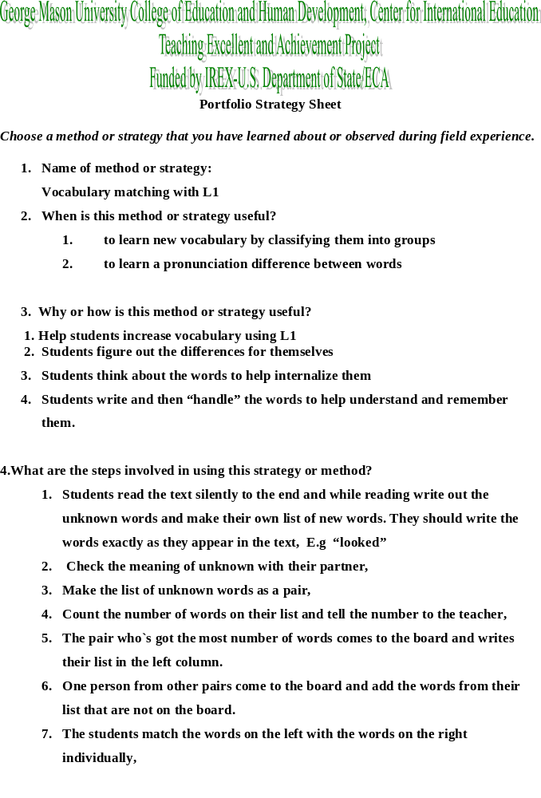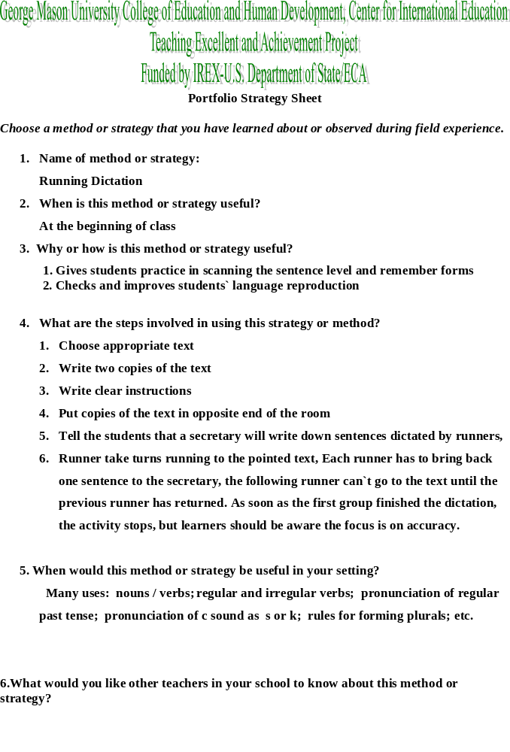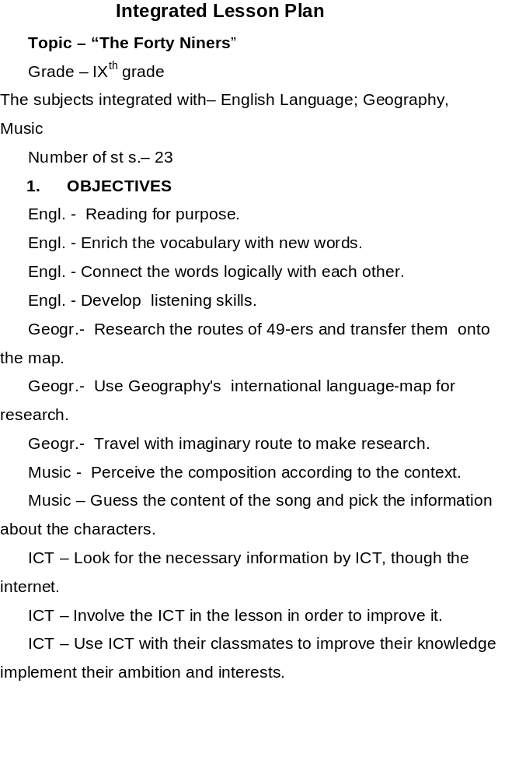

Holmes Middle School, located near Braddock Road in Annandale, is one of three Fairfax County middle schools with grades six, seven, and eight.
The central theme of the Holmes School Plan is to improve school achievement for all students. The school finds strength in its diverse population, exemplified by students and staff members representing more than 50 of the world’s countries. Teachers meet daily in their teams to plan lessons, and regularly meet by grade level to coordinate instruction and activities. Special education services are available for students with disabilities consistent with the recommendations of individualized education program teams. In addition, the needs of students in the following programs are met: school-based gifted and talented and English for speakers of other languages.
The curriculum is organized to maximize individual growth, academic skills, and opportunities for exploration of related and extracurricular activities. Staff members at Holmes are committed to providing a safe learning environment that stimulates student involvement and fosters learning and self-esteem. School goals and policy are shaped by the Middle School Council, a 25-member teacher leadership committee with active input from the PTA board. This unites the entire school community in the continuing mission of strengthening and enhancing learning opportunities for all students. The students are organized on six instructional teams, ranging from 130 to 150 members, that share the same language arts and English, mathematics, science, social studies, and resource teachers.

Co-teaching Process
- Warm-Up. Grade 7
Complete the sentences. Use the example:
My name is Angela. I am active. (Note: both words begin with the same letter “a”)
- Warm-Up. Grade 6.
On which continent is Ukraine located?
What countries border Ukraine?
Comparing the geographical features of Ukraine and the USA. Grade 6.
The students listen to the teacher telling them about the geography of Ukraine. The key-words are written on the blackboard. Then the students fill the T-diagram comparing the geography of Ukraine and the USA (individual work). The students report on their work making up sentences according to their T-diagrams.
- Reading Class. Grade 7.
Warm-Up.
- What is etiquette?
Give an example of etiquette?
- Anticipation Task
- Ukrainians address relatives and close friends by first names.
- Ukrainians are very hospitable.
- It is a custom in Ukraine to shake hands both with men and women.
- Do not whistle in the room.
- It is considered bad luck to shake hands across the threshold of a door.
- You should bring a small gift when you come to somebody’s house.

Main Activity
The students read the text “Ukrainian Etiquette”. They answer the teacher’s questions and check how well they have predicted the content. Then they fillin the in the graphic organizer “Venn-diagram”.
Wrap-Up
3 things - what you have learned about Ukraine;
2 things - what was the most interesting for you in the text;
1 thing – what else would you like to know about Ukraine.

- Cultural Lesson. Grades 6, 7.
Warm-up.
What do you already know about Ukraine?
Main Activity.
The students watch the slide-show about Ukraine and discuss the things being shown.
Wrap-up.
3 things – what was new for me;
2 things – what was completely different from the USA;
1 thing – I’d like to know more about.

- Vocabulary Work. Grade 6.
The students get cards with the key-words. They should explain the word, draw an illustration to it present the word to the class. (Group Work)
- Analyzing the text. Grade 7.
The students read a non-fiction text. The teacher discusses the text with the students. The objective is to find the main ideas and write a summary of the text.


October, 26 was a multicultural day for our group. Everybody was ready to present their countries, to show the most significant things that can display the soul of the nation.
We all had national costumes on. We took a lot of pictures. Everybody was very proud to share something very national with everybody.
Our Ukrainian team consists of three people. We are Olga Shevchenko, Nataly Kanarska and Olena Dmitrieva.
We showed our fellows the power point presentation which depicted the geographical location, the main regions, traditions of Ukraine. We shared with our friends some interesting facts about our dear Motherland.
Then everybody could watch a cartoon based on the Ukrainian folk-tale “There was once a dog”. This cartoon was so funny that all couldn’t help laughing.
It is great that we had an opportunity to share the information about our countries.
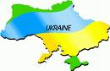

- Fullan, M. (2001). Leading in a culture of change. San Francisco: Jossey – Bass.
- Life Styles Inventory (LSI. Synergistic, Inc Classroom Materials).
- Armstrong, T. (2000). Multiple Intelligences in the Classroom. Alexandria: ASCD.
- Haley, M. (2010). Brain compatible differentiated instruction for English language learners. Pearson Education Inc., Boston. ISBN: 0-205-58239-7.
- O’Malley, J.M. & Valdez Pierce, L. (1996). Authentic assessment for English language learners: Practical approaches for teachers. Reading, MA: Pearson Education (formerly Addison Wesley Longman). ISBN: 978-0201591514.
- http://www.literacyworks.org/mi/assessment/index.html
- http://www.newhorizons.org/
- http://www.thirteen.org/edonline/concept2class/index.html
- www.familyeducation.com/topic/front/0,1156,1-12410,00.html
- www.pbs.org/wnet/gperf/education/ed_mi_overview.html
- http://trailfire.com/srlong/ trailview/63512

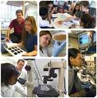You cannot be a real student if you don’t have any homework to do
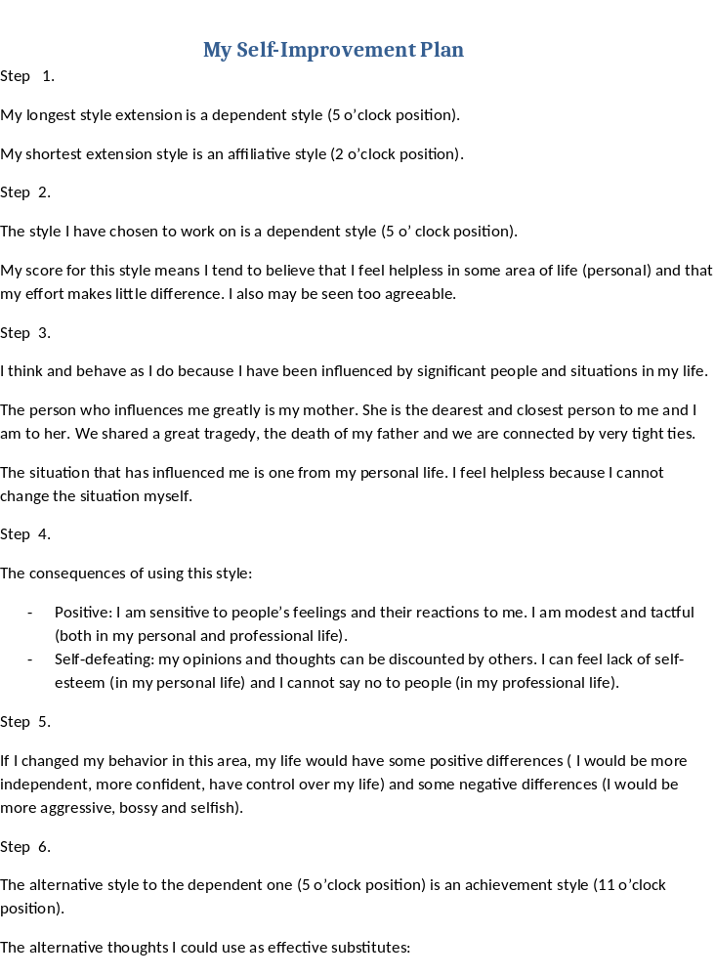
- knowing that individual effort counts;
- setting and accomplishing my own goals;
- giving honest feedback;
- being satisfied with myself.
Step 7.
The main challenges I will have are to learn to listen and act according to my own needs and wants and to learn to please myself first.
Step 8.
The barriers that prevent me from changing my behavior :
- Unwillingness to change;
- Fear of conflicts.
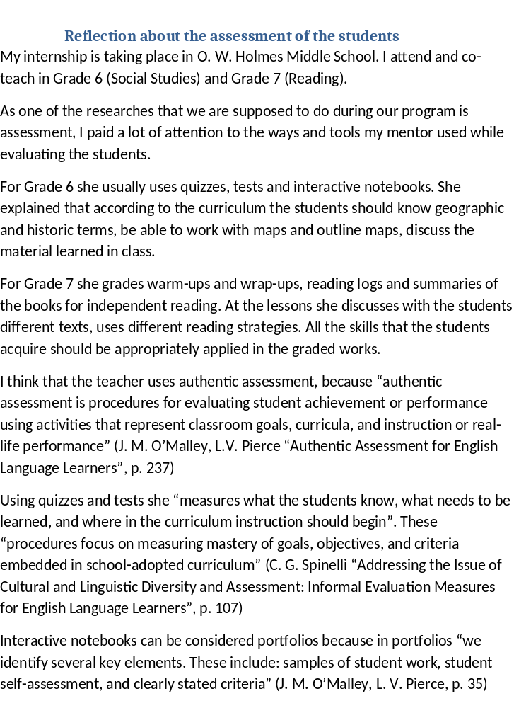
Reading logs is an effective tool for evaluating independent reading and observing how well the students can use reading strategies. “By reviewing reading logs for reading interest levels as well as for the quantity of materials read independently, teachers can provide feedback to students on their reading progress and on additional materials which may interest them ” (J. M. O’Malley, L. V. Pierce, p. 111)
Grading warm-ups, wrap-ups and summaries of the books for independent reading the teacher evaluates how well the students can apply the reading strategies, how they develop their ideas how creative they are in asking questions.
Back home I am going to implement such kinds of authentic assessment: portfolios (for giving my students and their parents an opportunity to trace the progress in learning), reading logs ( for encouraging my students to read in English and for improving their vocabulary, oral and writing skills).

Reference List:
- J. Michael O’Malley, Lorraine Valdez Pierce “Authentic Assessment for English Language Learners. Practical Approaches for Teachers”.
Cathleen G. Spinelli “Addressing the Issue of Cultural and Linguistic Diversity and Assessment: Informal Evaluation Measures for English Language Learners”. 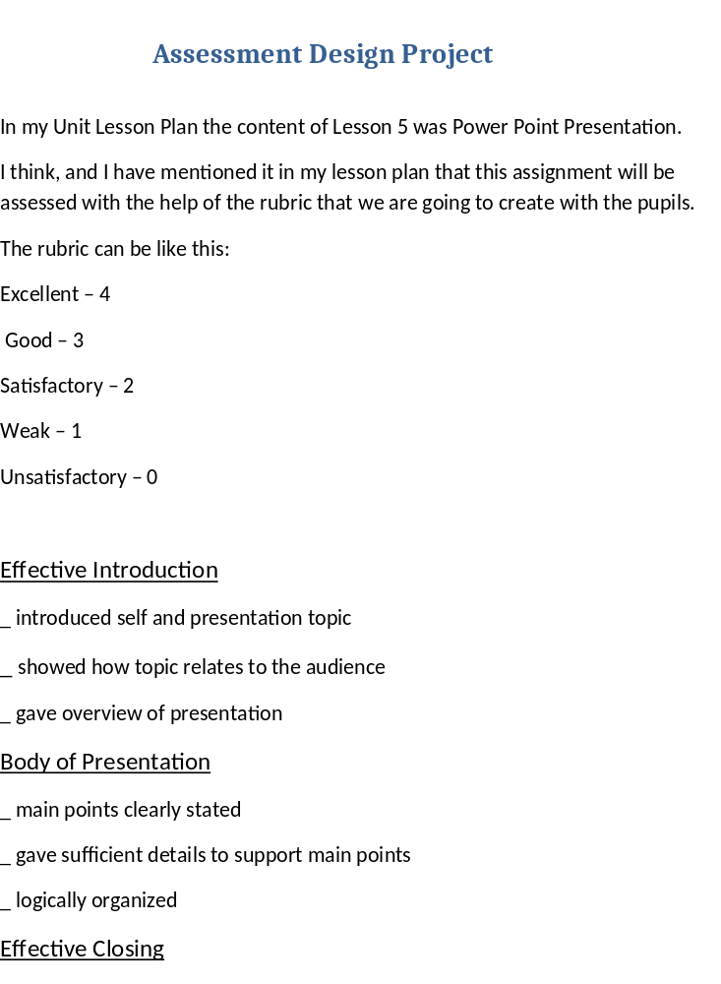_ reviewed presentation points
_ made a memorable closing point
Use of Presentation Language
_ used register vocabulary
_ used correct grammar
Overall Impression
_ well organized and prepared
Delivery
_ eye contact with audience
_posture/gestures
_pronunciation/clarity/volume
_ not read from screen or from notes
Power Point
_ concise information on each slide
_ correct grammar and spelling
I have chosen power point presentation as an assessment tool because I want to evaluate students’ oral speech and practice their presentation skills at the same time. I consider an analytic scoring rubric to be the most suitable in this case. “Analytic and weighted rating scales, while complicated and time-consuming to use, are most effective for communicating diagnostic information, such as students’ strengths and needs”(J. M. O’Malley, L. V. Pierce).
I like the idea of a rubric very much. It can fit my setting greatly. My task will be to think of appropriate criteria for different tasks.

Personal Leadership Plan

Vision/Mission
The project I am planning to work on is Lesson Study.
The goals of it are
- To encourage experienced teachers to spreading their best ideas;
- To assist young teachers;
- To work collaboratively on the most difficult for learning material;
- To create and promote functioning of the Professional Learning Community (PLC) in my school and then in my town.

Planning Calendar
The pilot project will start in January, 2010. I think it will take at least 1 year to introduce it and see the first results.

Results
The success can be measured by assessing the students’ skills in the area of the Lesson Study process.

Leadership Practices
Introducing this project into practice I will implement one of the ideas I have learned here and I will prove myself that I can make changes.

After I have done my portfolio, I should analyze it. Here are the questions for portfolio revision:
- Is my portfolio clearly organized?
- Are my goals realistic?
- Is my portfolio colorful?
- Does my portfolio show the results of my work?
- Will my portfolio be useful?
- Are the lessons plans practical?
- Does my portfolio show professional development?
- Is the portfolio coherent?
I answer “yes” to all these questions. I have leaned a lot, and I am taking home a lot of useful and practical things that I can combine with the Ukrainian practices and implement in my school.
I am grateful to all the instructors who conducted seminars. Dr. Farnoosh Shahrokhi, Dr. Sherry Steeley, Dr. Beverly Woody, Nora Elbilawi are professionals in their field, they are very competent and friendly.
Thank you, George Mason University, for having been our host university.

